PCA-SIMS Spectra Analysis Report

**Soil Carbon Cycling/Lignin**

ToF-SIMS testing date: 20221123/20230207

ToF-SIMS operator: Ping Chen

# 2D PCA scores plots

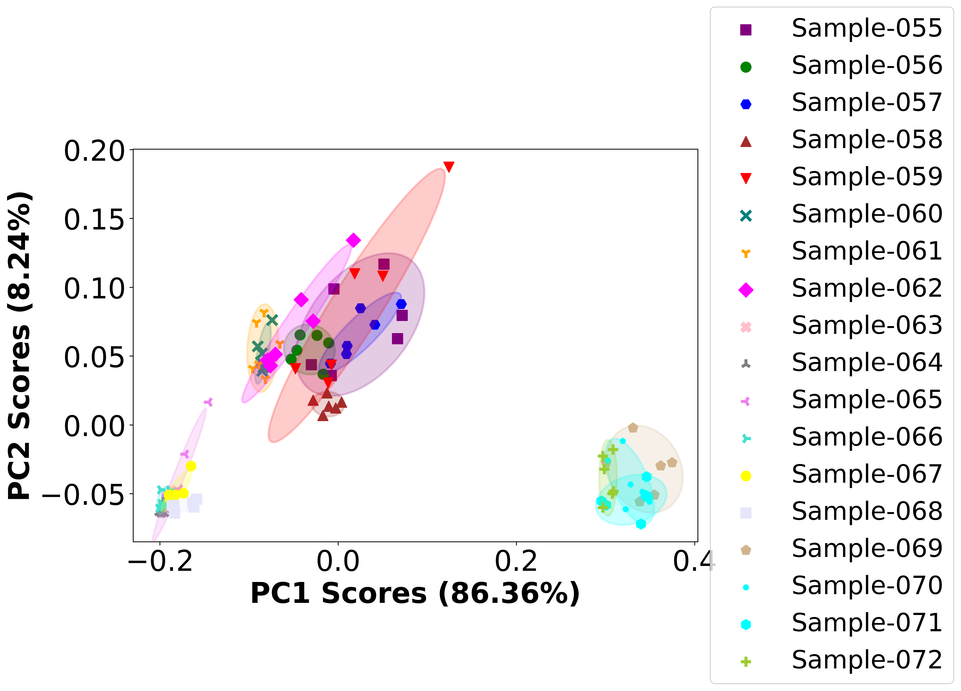

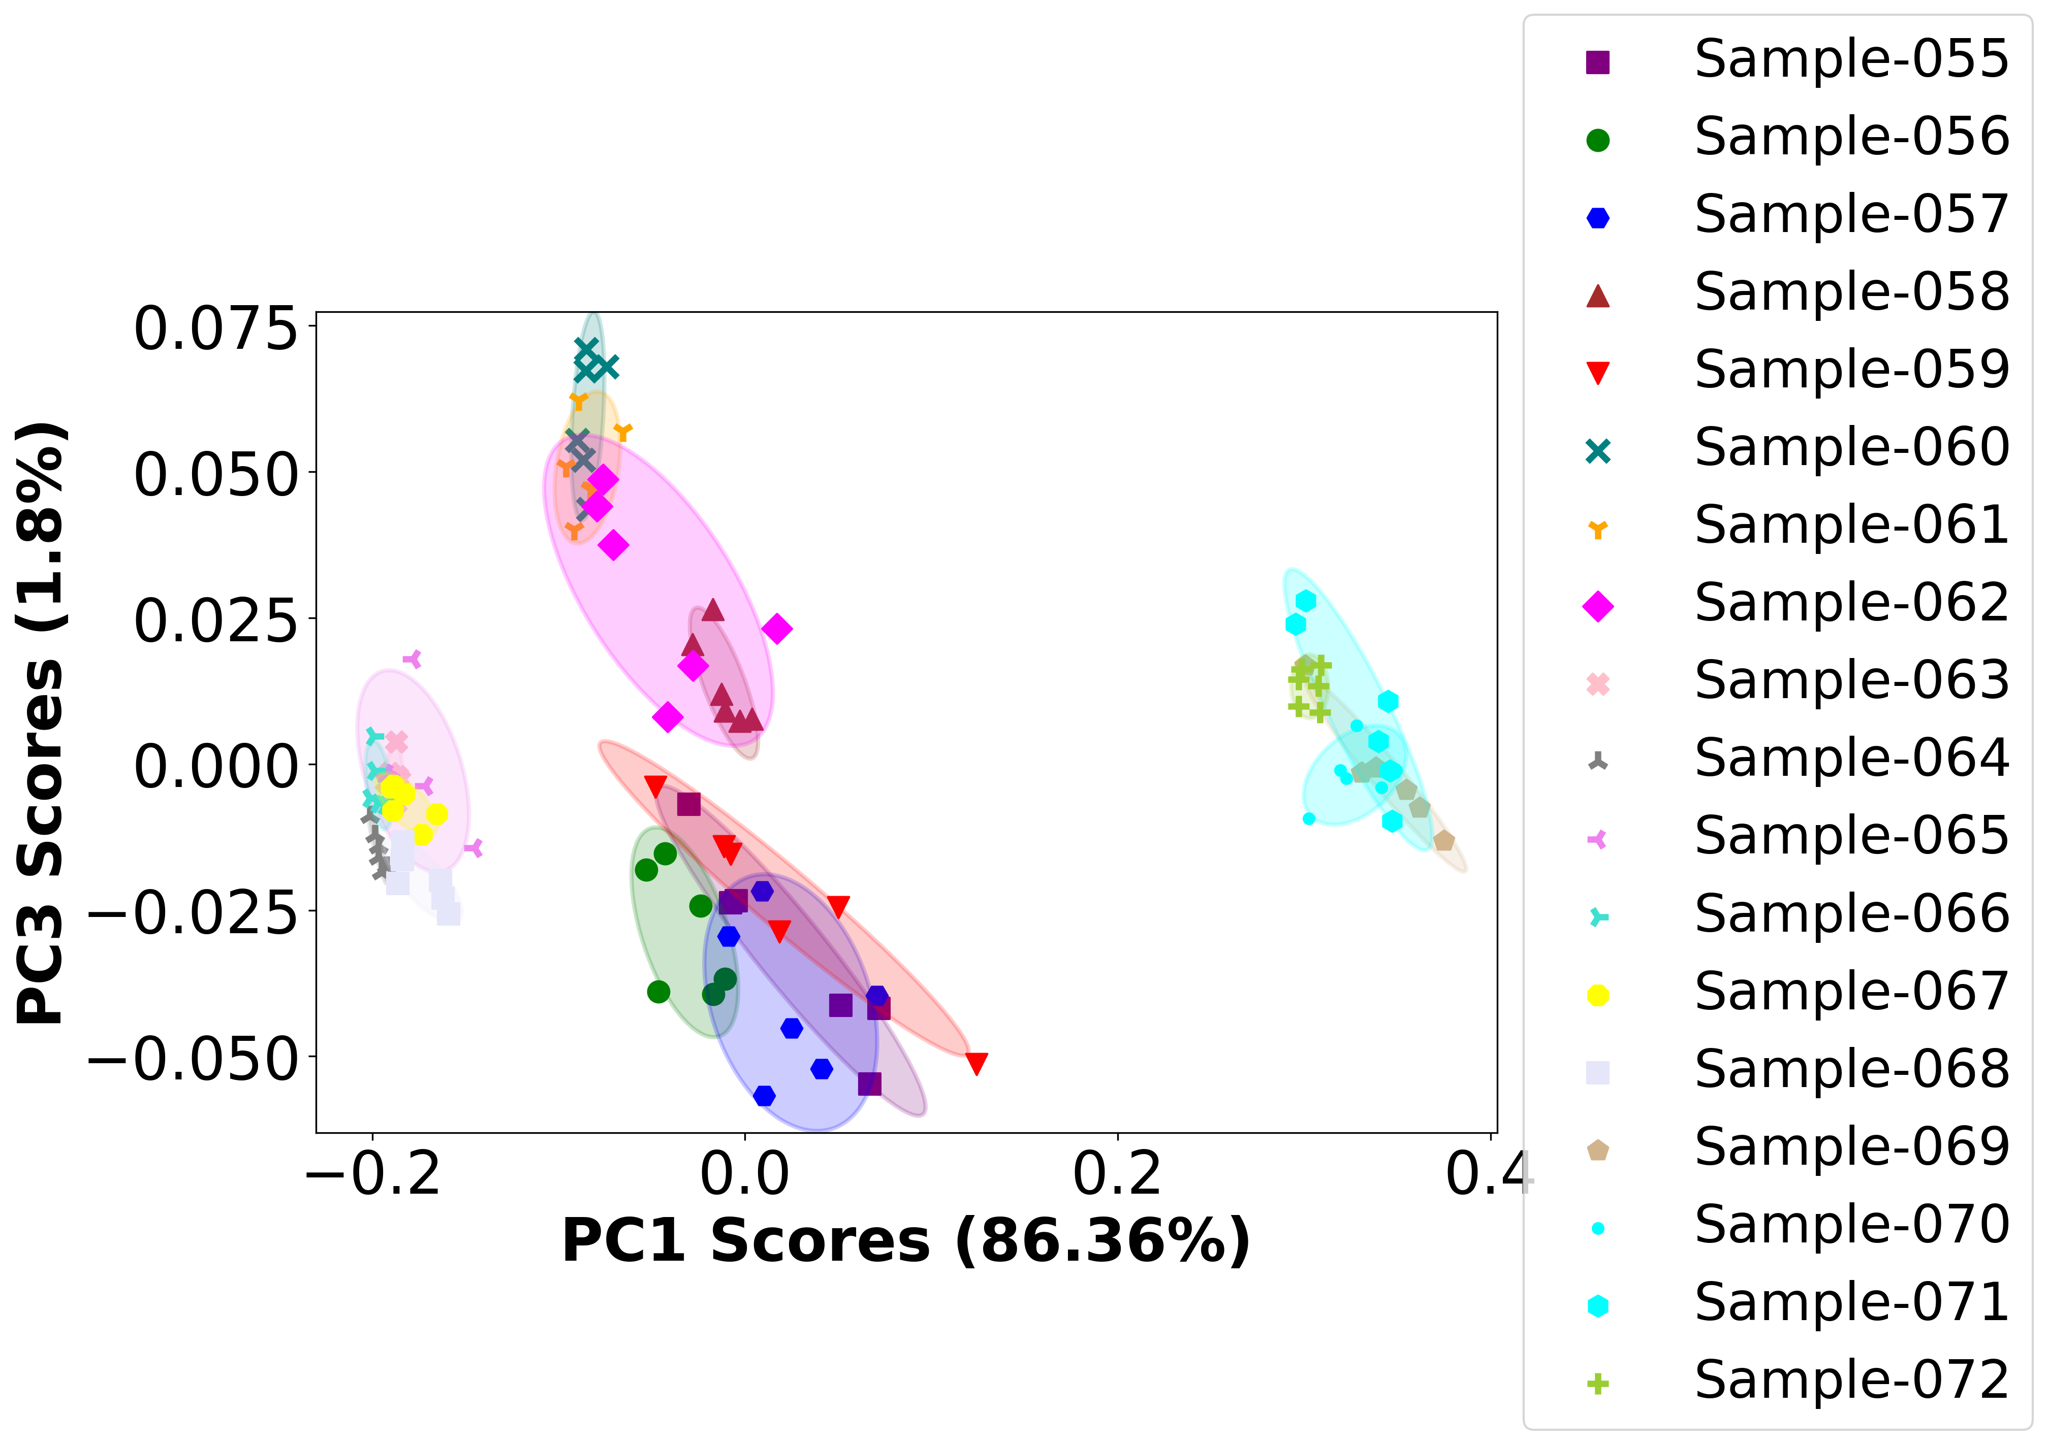

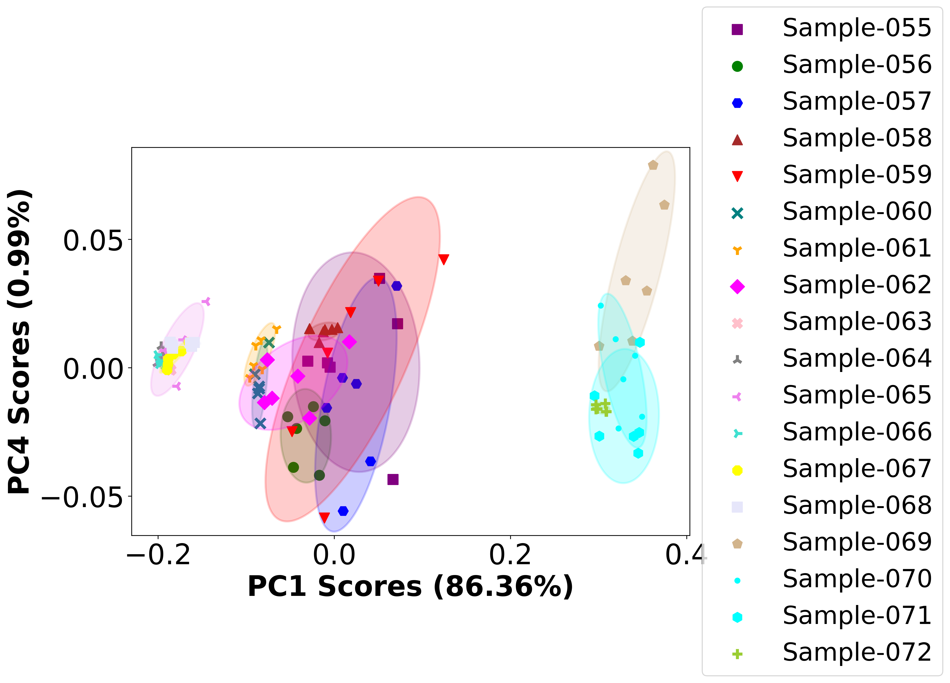

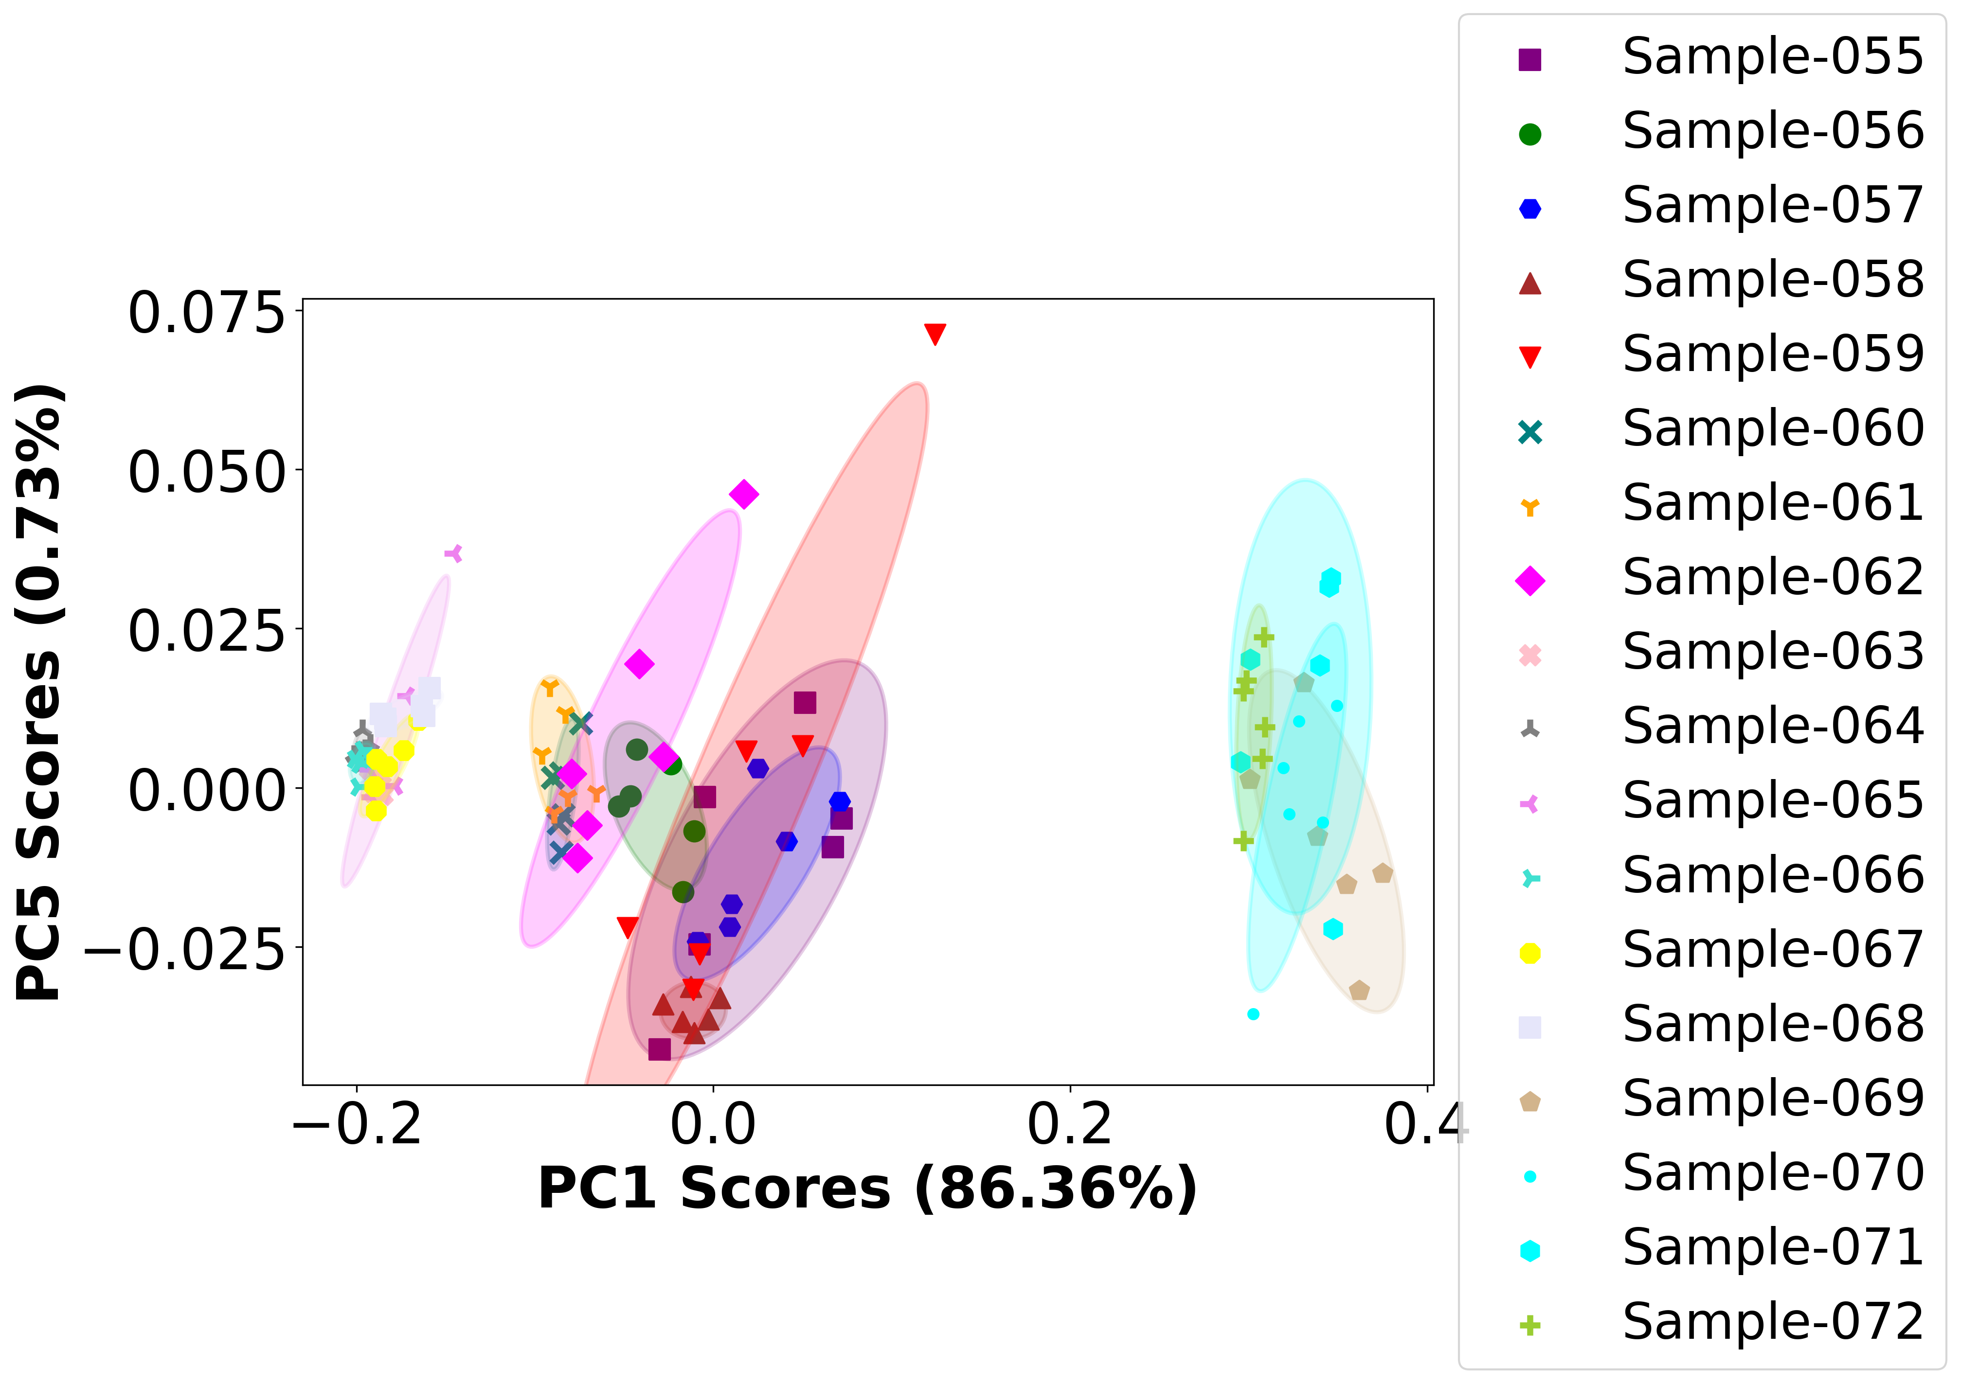

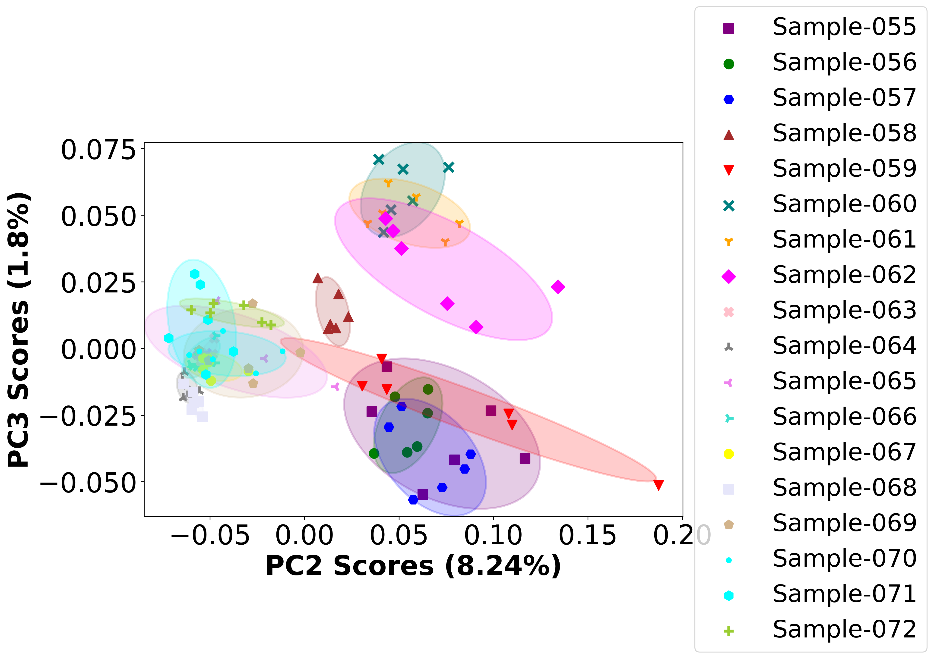

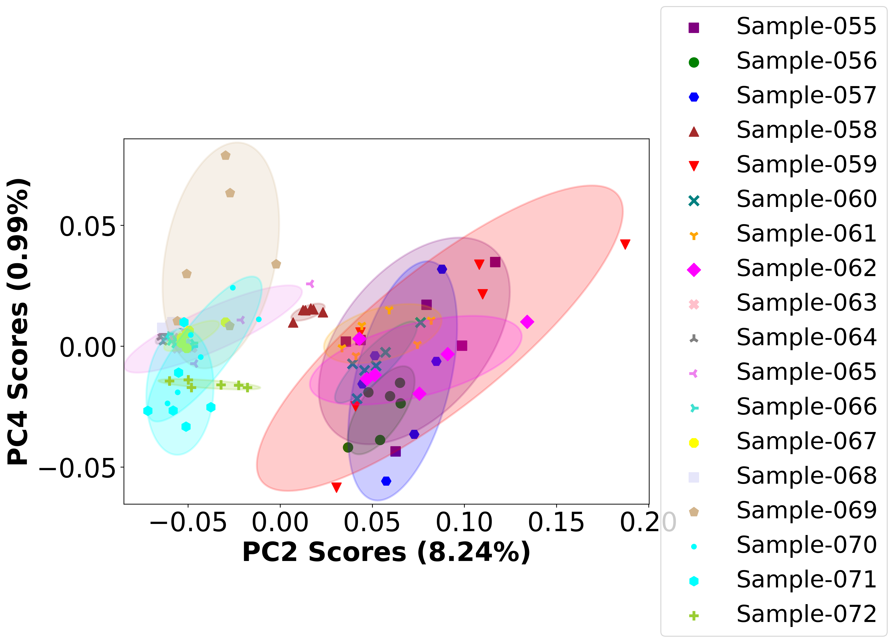

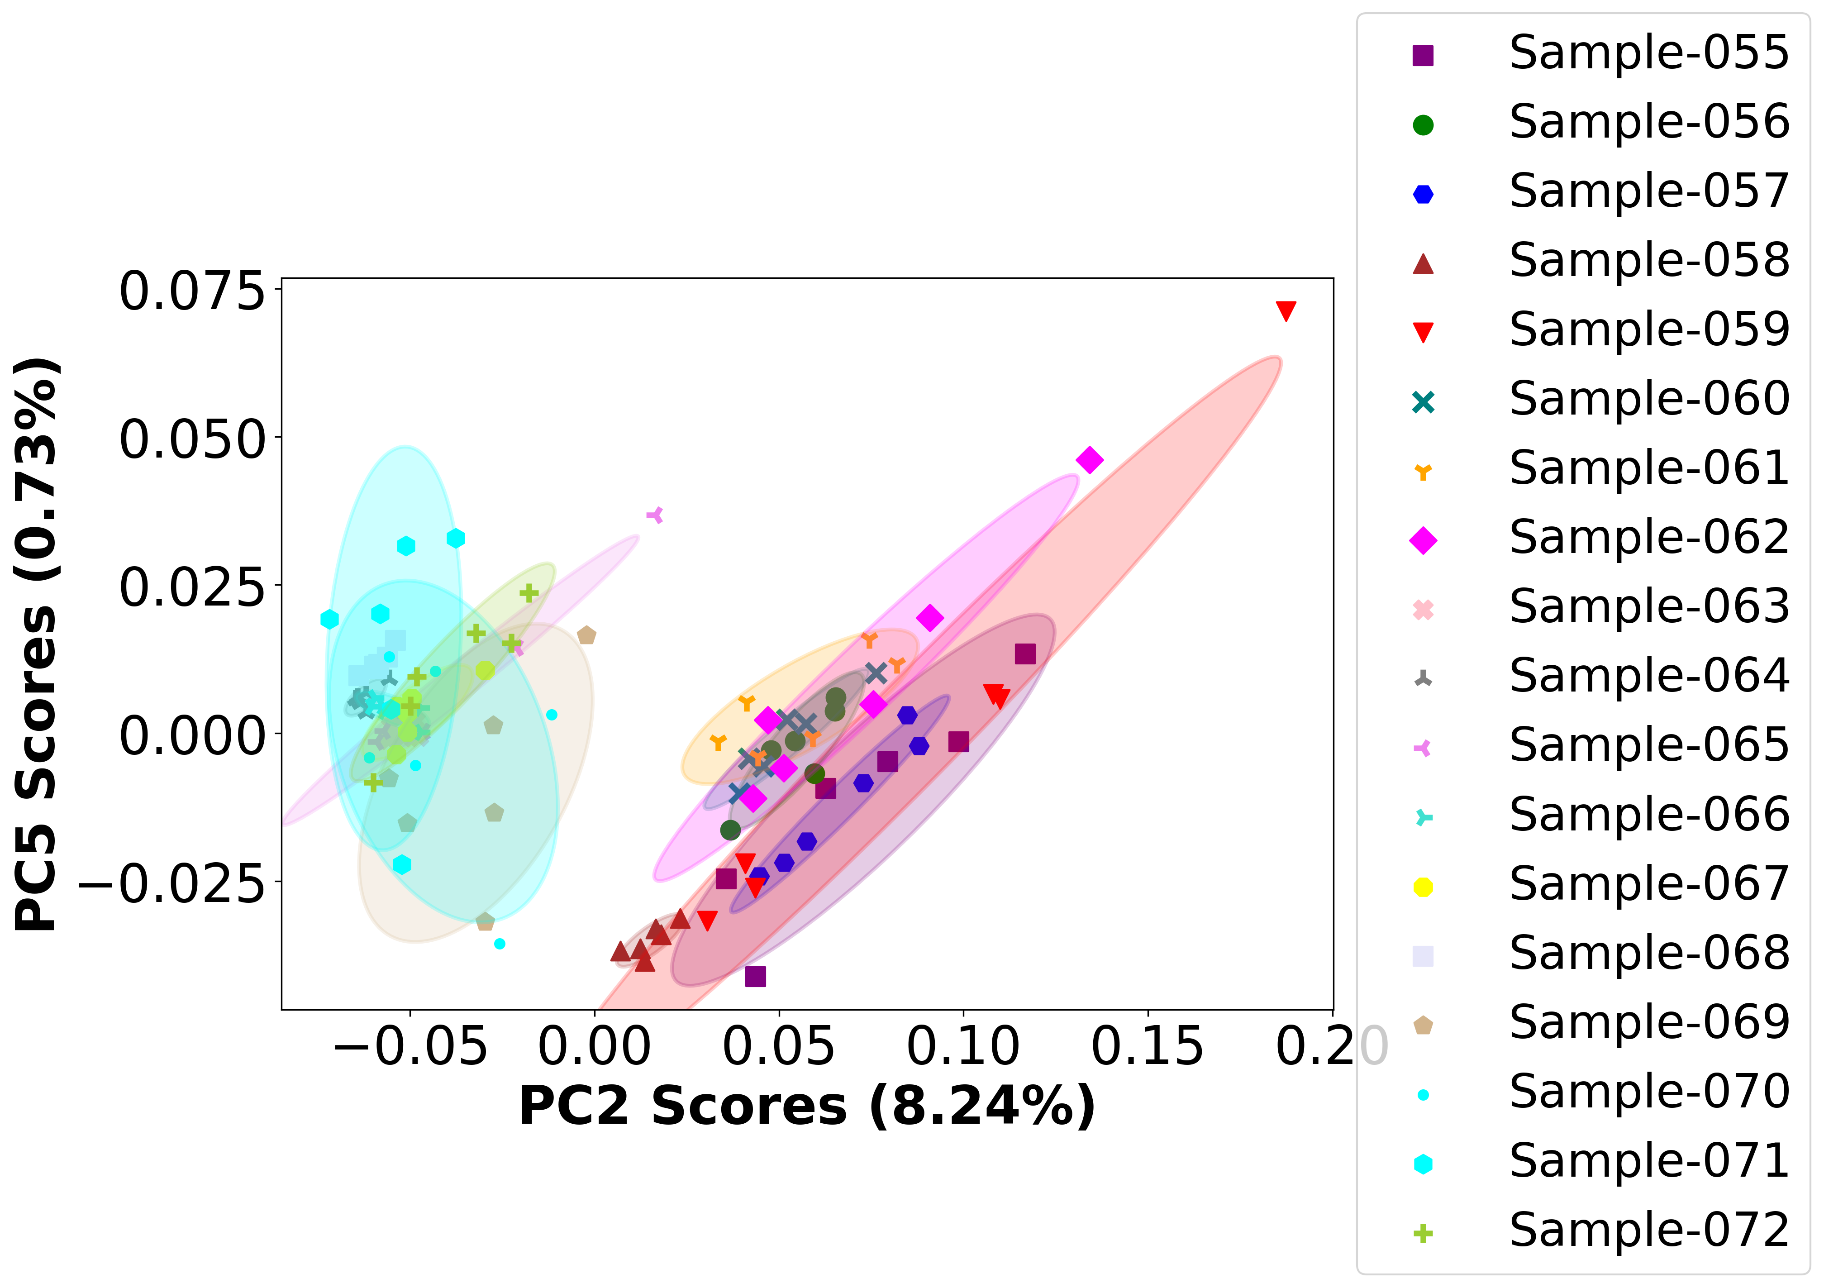

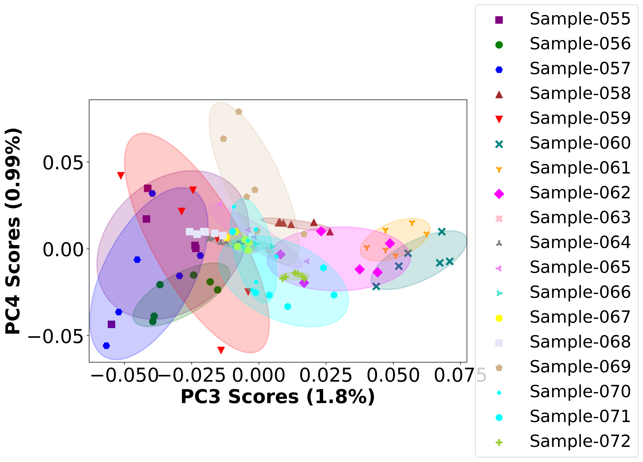

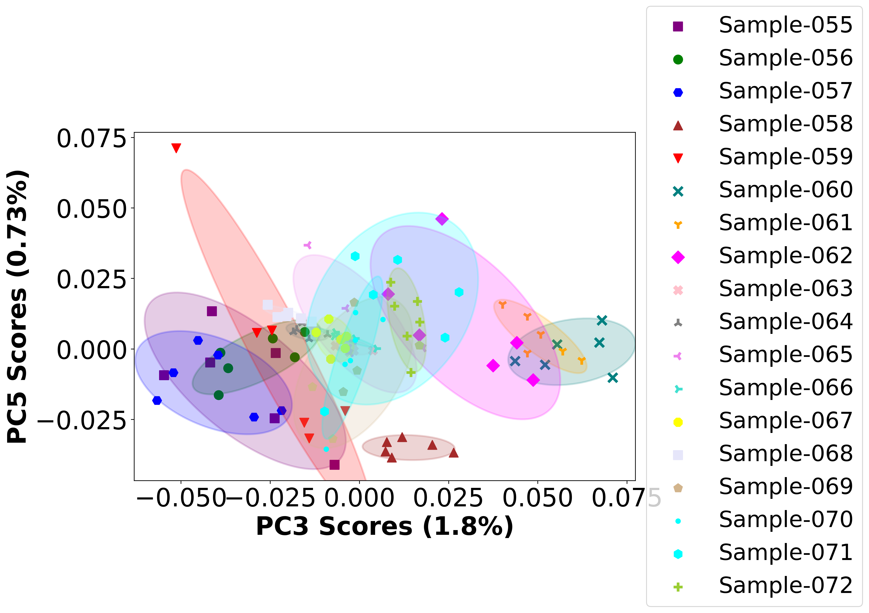

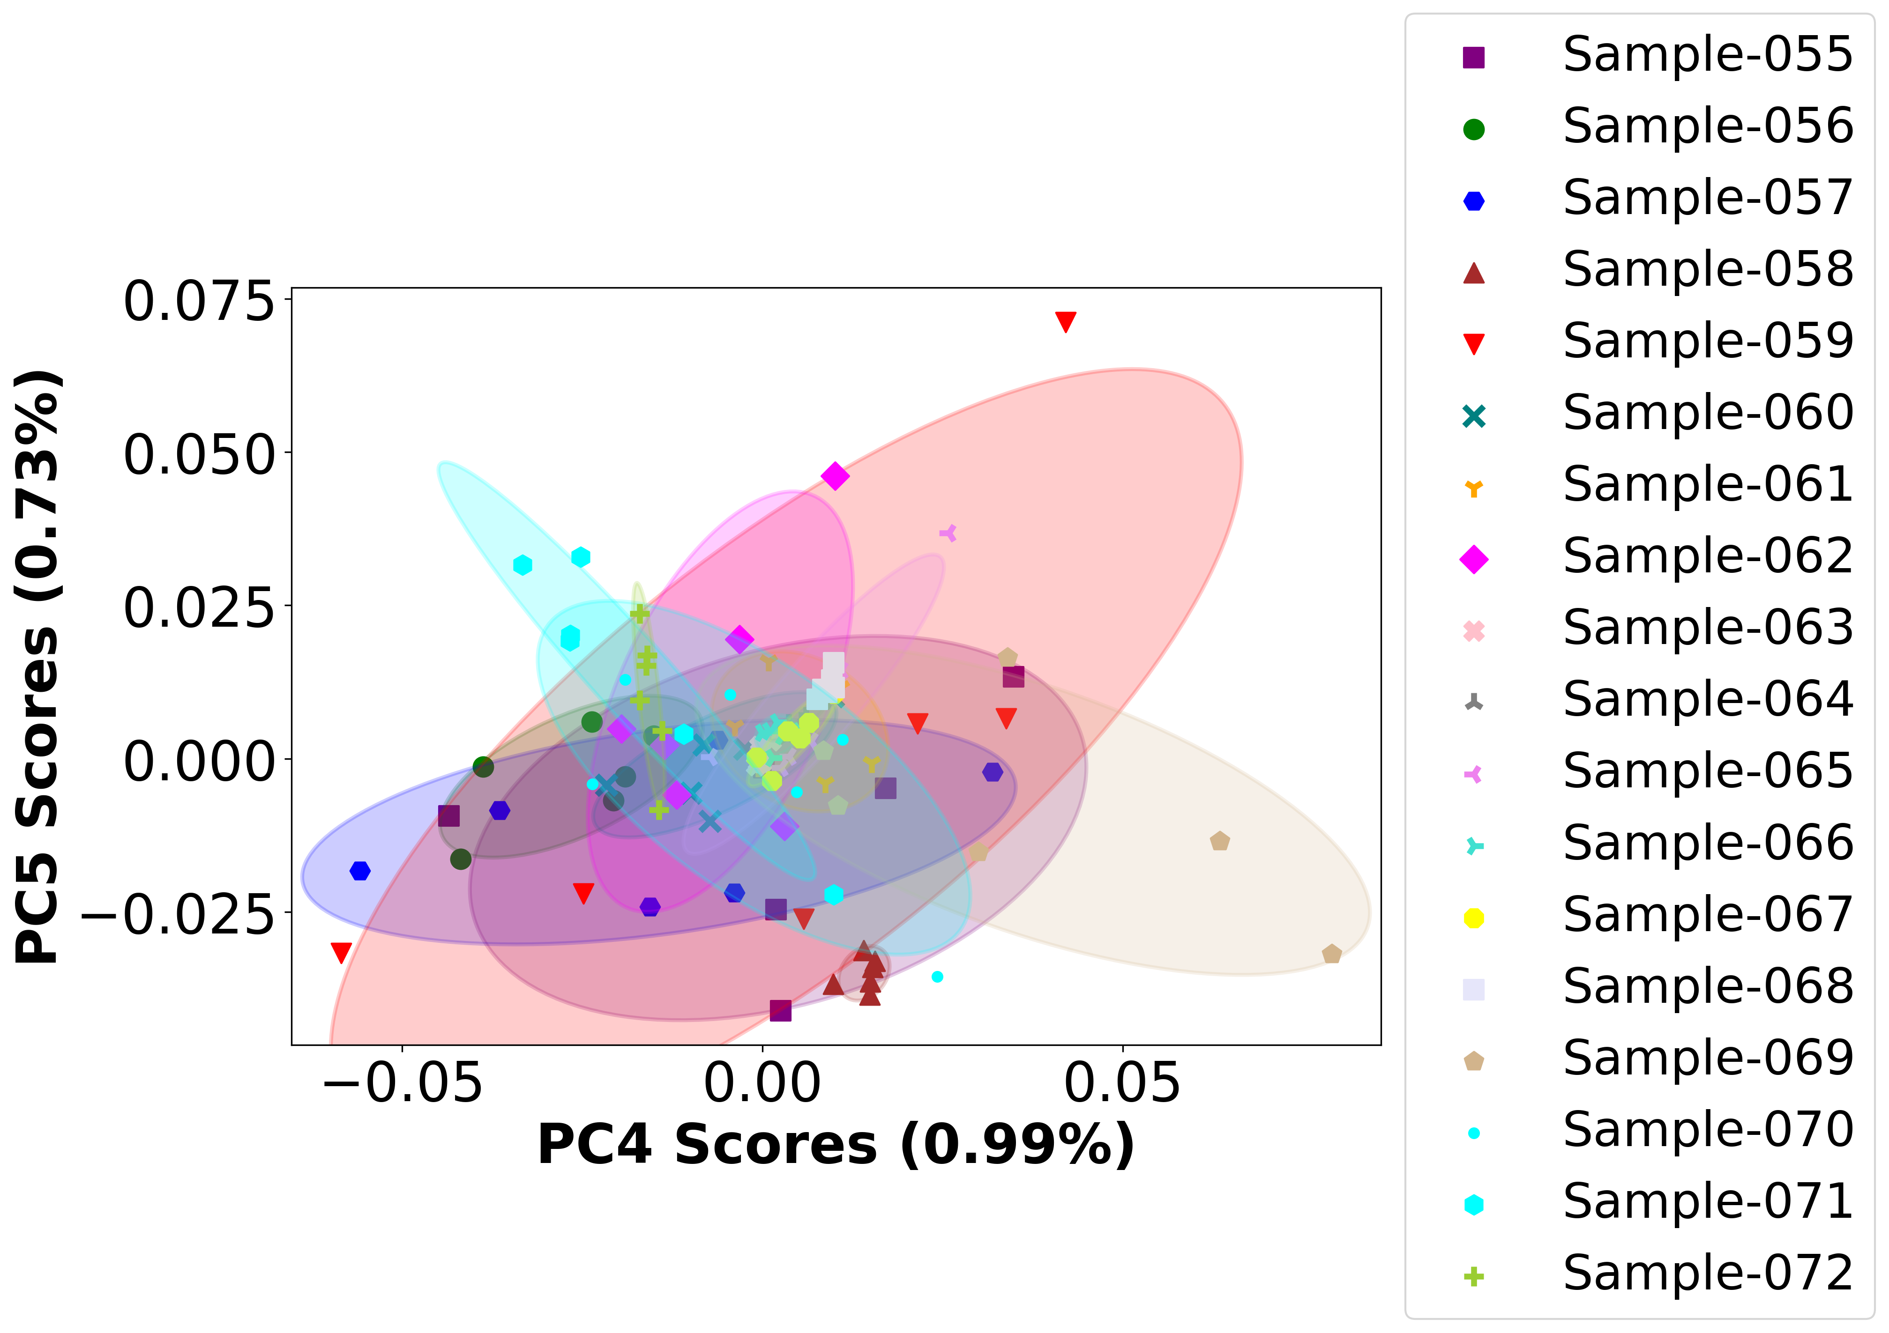

# Positive ion spectra, PCA analysis results -- PC1

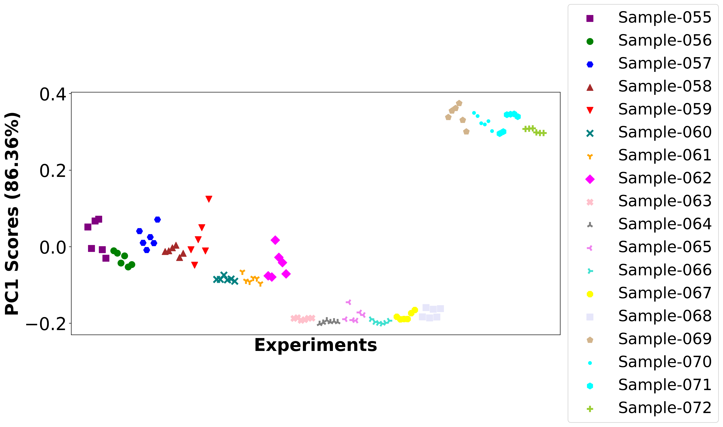

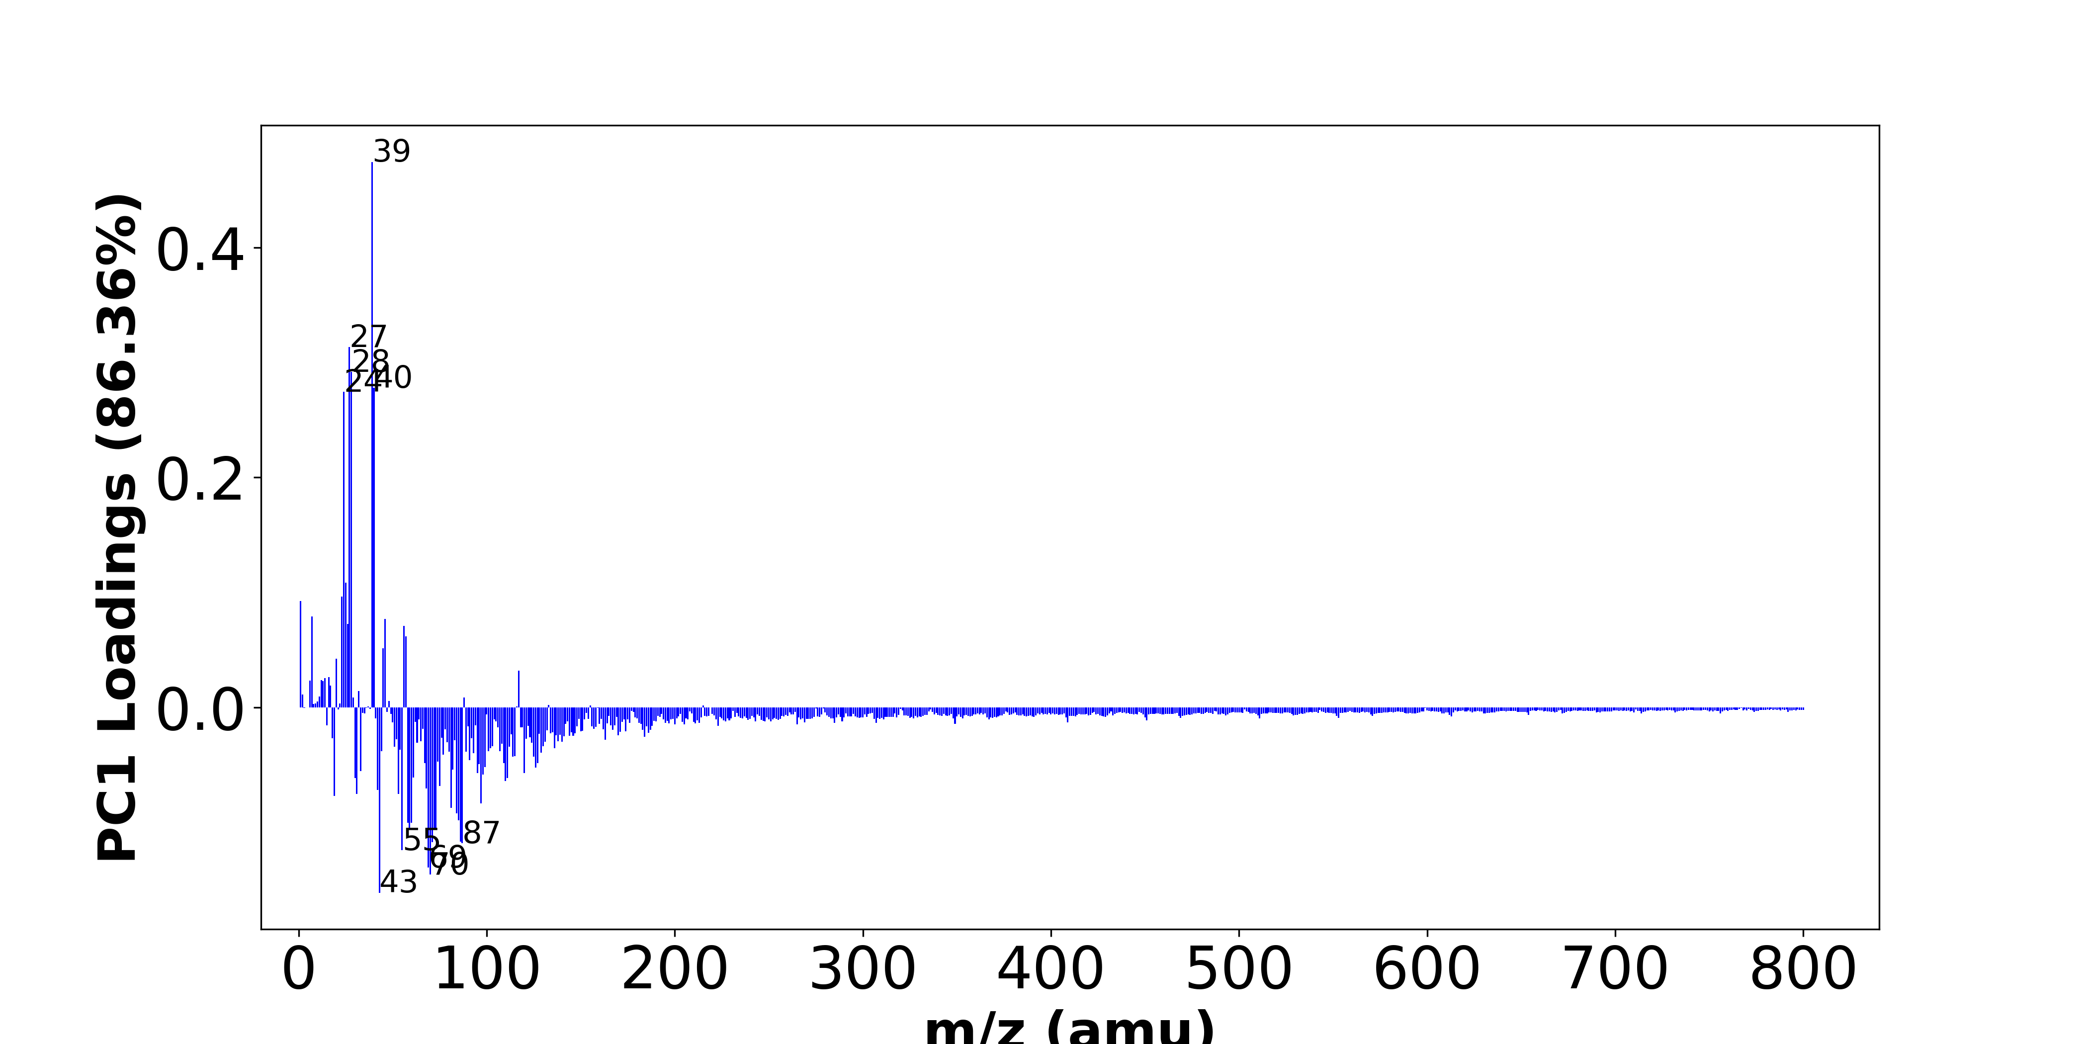

High score samples contain more:

* m/z 39 (K+,C3H3+), m/z 27 (Al+,C2H3+), m/z 28 (Si+), m/z 40 (Ca+), m/z 24 (Mg+), m/z 25 (25Mg+), m/z 23 (Na+), m/z 1 (H+), m/z 7 (Li+), m/z 46 (Na2+,C2H8N+), m/z 26 (26Mg+), m/z 56 (Fe+,Si2+,C3H6N+), m/z 57 (C4H9+,CaOH+), m/z 45 (SiOH+,C2H5O+), m/z 20 (Ca++), m/z 117 (-), m/z 16 (-), m/z 14 (-), m/z 12 (C+), m/z 6 (6Li+),
* Hydrocarbon

Low score samples contain more:

* m/z 43 (C3H7+), m/z 70 (C4H8N+), m/z 69 (-), m/z 55 (C4H7+), m/z 87 (-), m/z 71 (-), m/z 86 (C5H12N+), m/z 73 (SiC3H9+), m/z 72 (-), m/z 59 (-), m/z 60 (-), m/z 58 (-), m/z 85 (-), m/z 84 (-), m/z 81 (-), m/z 97 (-), m/z 19 (OH3+), m/z 31 (OCH3+), m/z 53 (C4H5+), m/z 42 (-),
* Oxygen-contained organics, Nitrogen-contained organics

# Positive ion spectra, top positive loadings -- PC1

|  |  |  |  |  |  |  |
| --- | --- | --- | --- | --- | --- | --- |
| + loading | No. # | Unit Mass | Document Mass | Initial Peak Assignment | Measured Mass | Updated Peak Assignment |
|  | 1 | 39 | 38.9632,39.023 | K+,C3H3+ |  |  |
|  | 2 | 27 | 26.981,27.023 | Al+,C2H3+ |  |  |
|  | 3 | 28 | 27.9764 | Si+ |  |  |
|  | 4 | 40 | 39.962 | Ca+ |  |  |
|  | 5 | 24 | 23.9845 | Mg+ |  |  |
|  | 6 | 25 | 24.9853 | 25Mg+ |  |  |
|  | 7 | 23 | 22.9892 | Na+ |  |  |
|  | 8 | 1 | 1.0073 | H+ |  |  |
|  | 9 | 7 | 7.0155 | Li+ |  |  |
|  | 10 | 46 | 45.979,46.0652 | Na2+,C2H8N+ |  |  |
|  | 11 | 26 | 25.982 | 26Mg+ |  |  |
|  | 12 | 56 | 55.9344,55.9534,56.0495 | Fe+,Si2+,C3H6N+ |  |  |
|  | 13 | 57 | 57.0699,56.9648 | C4H9+,CaOH+ |  |  |
|  | 14 | 45 | 44.9792,45.0335 | SiOH+,C2H5O+ |  |  |
|  | 15 | 20 | 19.9807 | Ca++ |  |  |
|  | 16 | 117 |  |  |  |  |
|  | 17 | 16 |  |  |  |  |
|  | 18 | 14 |  |  |  |  |
|  | 19 | 12 | 11.9995 | C+ |  |  |
|  | 20 | 6 | 6.0146 | 6Li+ |  |  |

# Positive ion spectra, top negative loadings -- PC1

|  |  |  |  |  |  |  |
| --- | --- | --- | --- | --- | --- | --- |
| - loading | No. # | Unit Mass | Document Mass | Initial Peak Assignment | Measured Mass | Updated Peak Assignment |
|  | 1 | 43 | 43.0543 | C3H7+ |  |  |
|  | 2 | 70 | 70.0652 | C4H8N+ |  |  |
|  | 3 | 69 |  |  |  |  |
|  | 4 | 55 | 55.0543 | C4H7+ |  |  |
|  | 5 | 87 |  |  |  |  |
|  | 6 | 71 |  |  |  |  |
|  | 7 | 86 | 86.0965 | C5H12N+ |  |  |
|  | 8 | 73 | 73.0469 | SiC3H9+ |  |  |
|  | 9 | 72 |  |  |  |  |
|  | 10 | 59 |  |  |  |  |
|  | 11 | 60 |  |  |  |  |
|  | 12 | 58 |  |  |  |  |
|  | 13 | 85 |  |  |  |  |
|  | 14 | 84 |  |  |  |  |
|  | 15 | 81 |  |  |  |  |
|  | 16 | 97 |  |  |  |  |
|  | 17 | 19 | 19.0179 | OH3+ |  |  |
|  | 18 | 31 | 31.0179 | OCH3+ |  |  |
|  | 19 | 53 | 53.0386 | C4H5+ |  |  |
|  | 20 | 42 |  |  |  |  |

# Positive ion spectra, molecular information from PC1 loadings plot

* The major positive PC1 loadings are m/z 39 (K+,C3H3+), m/z 27 (Al+,C2H3+), m/z 28 (Si+), m/z 40 (Ca+), m/z 24 (Mg+), m/z 25 (25Mg+), m/z 23 (Na+), m/z 1 (H+), m/z 7 (Li+), m/z 46 (Na2+,C2H8N+), m/z 26 (26Mg+), m/z 56 (Fe+,Si2+,C3H6N+), m/z 57 (C4H9+,CaOH+), m/z 45 (SiOH+,C2H5O+), m/z 20 (Ca++), m/z 117 (-), m/z 16 (-), m/z 14 (-), m/z 12 (C+), m/z 6 (6Li+), , indicating they are more observed in high PC1 score samples.
* The major negative PC1 loadings are m/z 43 (C3H7+), m/z 70 (C4H8N+), m/z 69 (-), m/z 55 (C4H7+), m/z 87 (-), m/z 71 (-), m/z 86 (C5H12N+), m/z 73 (SiC3H9+), m/z 72 (-), m/z 59 (-), m/z 60 (-), m/z 58 (-), m/z 85 (-), m/z 84 (-), m/z 81 (-), m/z 97 (-), m/z 19 (OH3+), m/z 31 (OCH3+), m/z 53 (C4H5+), m/z 42 (-), , indicating they are more observed in high PC1 score samples.
* Hydrocarbon signals, such as m/z 27 (Al+,C2H3+), m/z 57 (C4H9+,CaOH+), , are majorly found in positive loadings, indicating that high PC1 score samples contain more Hydrocarbon.
* Oxygen-contained organics signals, such as m/z 31 (OCH3+), m/z 19 (OH3+), , are majorly found in negative loadings, indicating that high PC1 score samples contain more Oxygen-contained organics.
* Nitrogen-contained organics signals, such as m/z 70 (C4H8N+), m/z 86 (C5H12N+), , are majorly found in negative loadings, indicating that high PC1 score samples contain more Nitrogen-contained organics.

# Positive ion spectra, PCA analysis results -- PC2

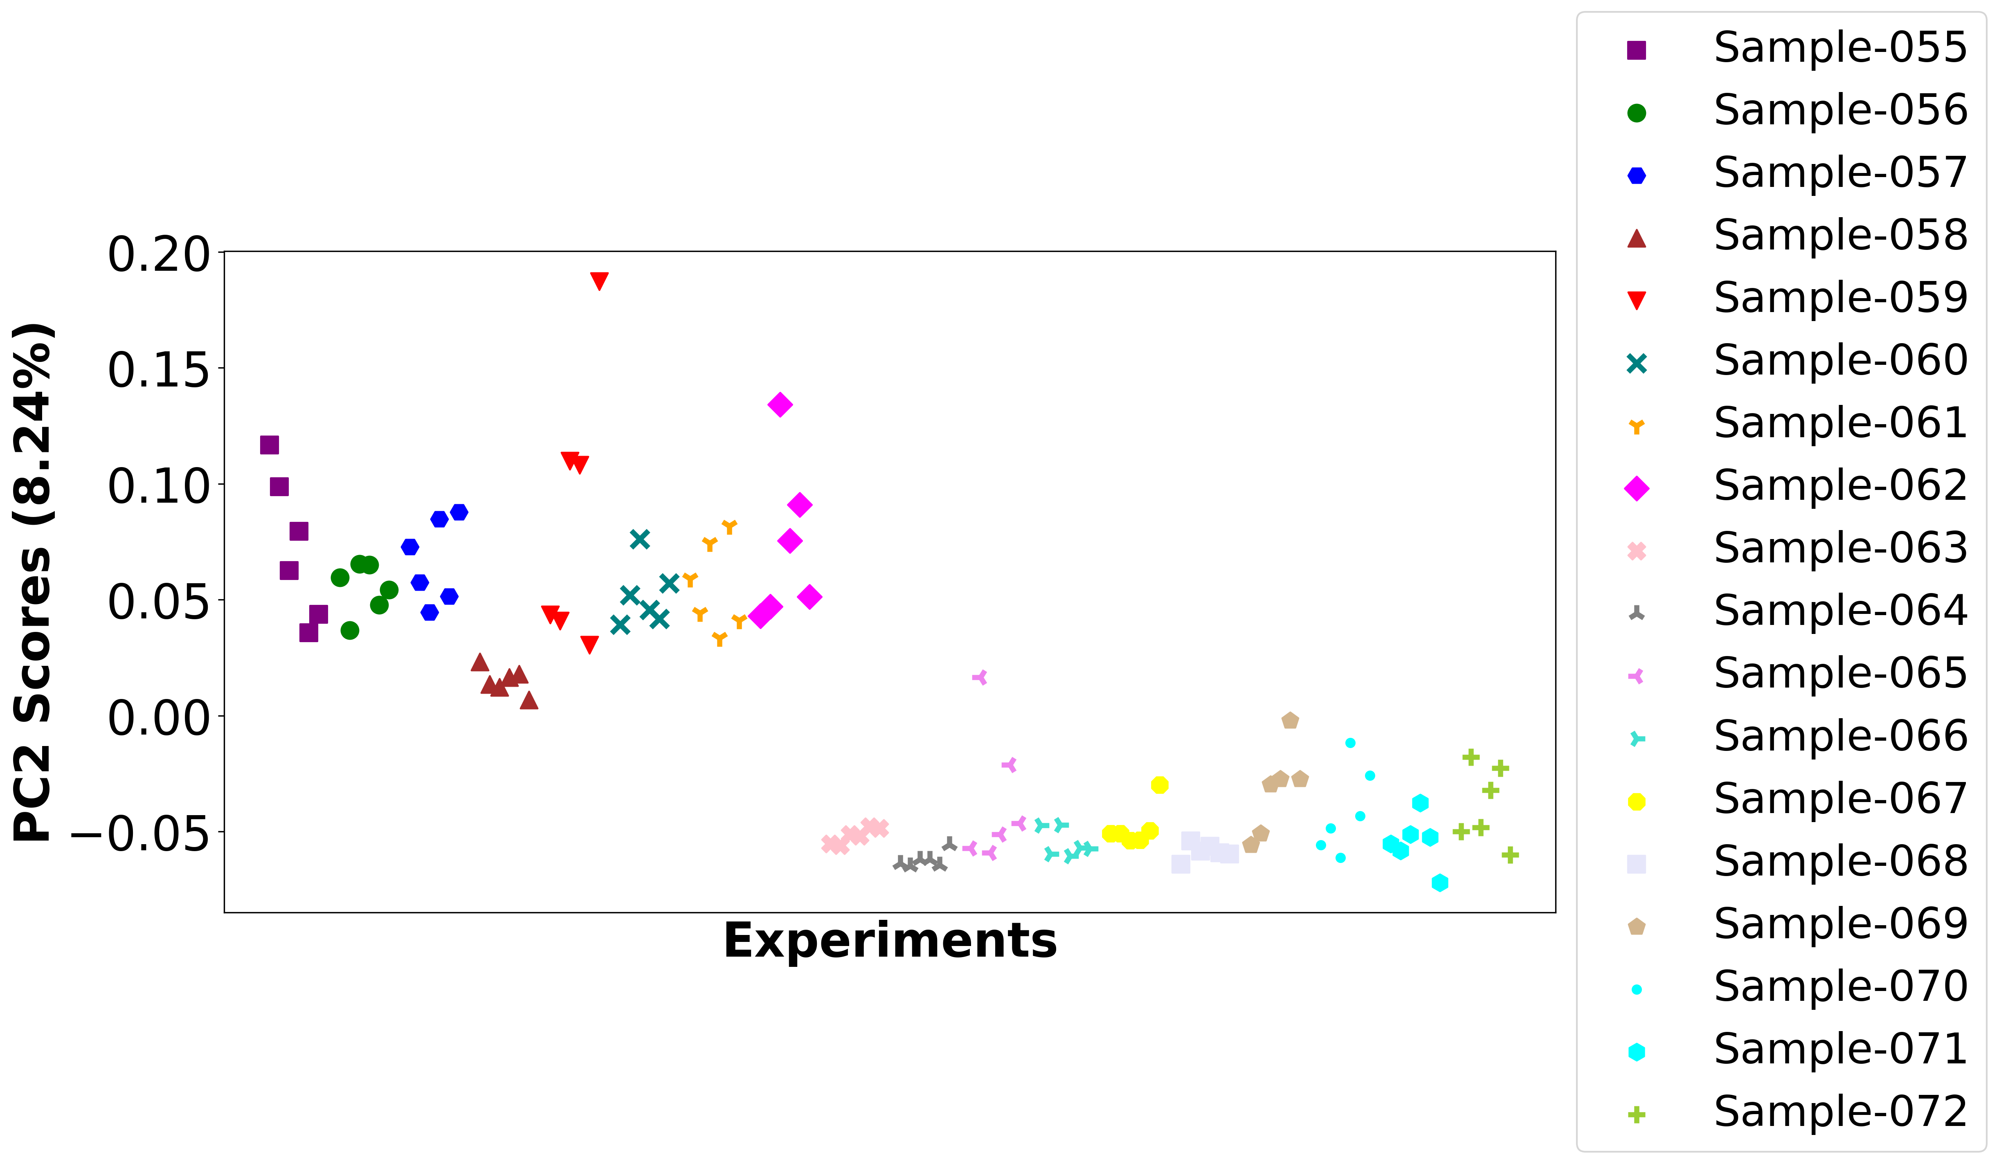

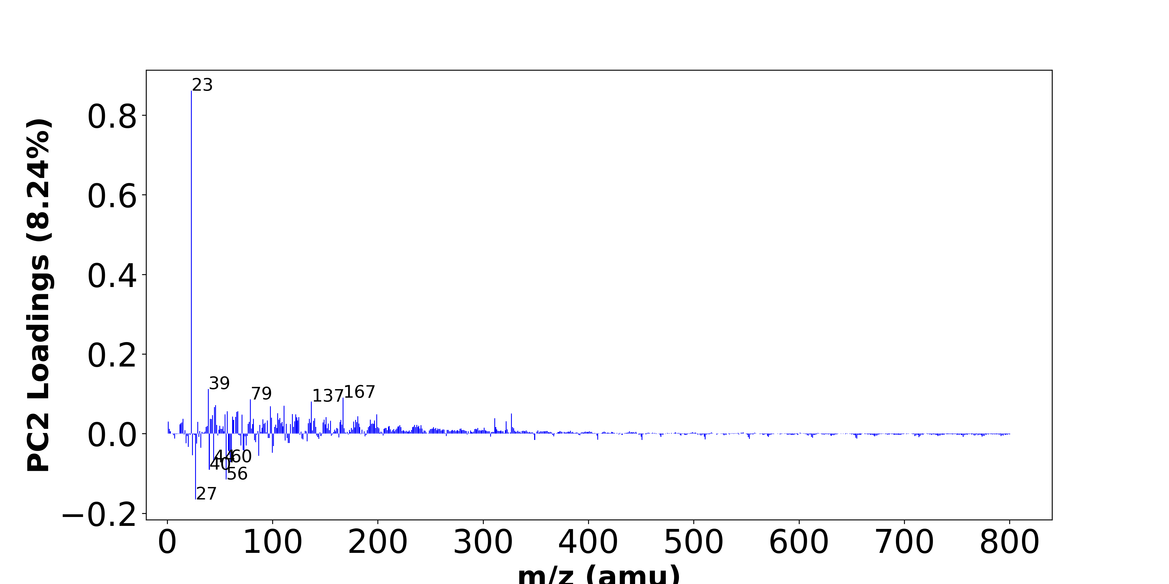

High score samples contain more:

* m/z 23 (Na+), m/z 39 (K+,C3H3+), m/z 167 (-), m/z 79 (-), m/z 137 (-), m/z 46 (Na2+,C2H8N+), m/z 111 (-), m/z 98 (-), m/z 45 (SiOH+,C2H5O+), m/z 67 (-), m/z 57 (C4H9+,CaOH+), m/z 66 (-), m/z 105 (C8H9+), m/z 327 (-), m/z 119 (-), m/z 55 (C4H7+), m/z 199 (-), m/z 122 (-), m/z 71 (-), m/z 43 (C3H7+),
* Hydrocarbon

Low score samples contain more:

* m/z 27 (Al+,C2H3+), m/z 56 (Fe+,Si2+,C3H6N+), m/z 40 (Ca+), m/z 44 (C2H6N+), m/z 60 (-), m/z 87 (-), m/z 24 (Mg+), m/z 59 (-), m/z 61 (-), m/z 73 (SiC3H9+), m/z 100 (-), m/z 58 (-), m/z 72 (-), m/z 32 (-), m/z 20 (Ca++), m/z 101 (-), m/z 70 (C4H8N+), m/z 75 (-), m/z 28 (Si+), m/z 18 (NH4+),
* Nitrogen-contained organics

# Positive ion spectra, top positive loadings -- PC2

|  |  |  |  |  |  |  |
| --- | --- | --- | --- | --- | --- | --- |
| + loading | No. # | Unit Mass | Document Mass | Initial Peak Assignment | Measured Mass | Updated Peak Assignment |
|  | 1 | 23 | 22.9892 | Na+ |  |  |
|  | 2 | 39 | 38.9632,39.023 | K+,C3H3+ |  |  |
|  | 3 | 167 |  |  |  |  |
|  | 4 | 79 |  |  |  |  |
|  | 5 | 137 |  |  |  |  |
|  | 6 | 46 | 45.979,46.0652 | Na2+,C2H8N+ |  |  |
|  | 7 | 111 |  |  |  |  |
|  | 8 | 98 |  |  |  |  |
|  | 9 | 45 | 44.9792,45.0335 | SiOH+,C2H5O+ |  |  |
|  | 10 | 67 |  |  |  |  |
|  | 11 | 57 | 57.0699,56.9648 | C4H9+,CaOH+ |  |  |
|  | 12 | 66 |  |  |  |  |
|  | 13 | 105 | 105.0699 | C8H9+ |  |  |
|  | 14 | 327 |  |  |  |  |
|  | 15 | 119 |  |  |  |  |
|  | 16 | 55 | 55.0543 | C4H7+ |  |  |
|  | 17 | 199 |  |  |  |  |
|  | 18 | 122 |  |  |  |  |
|  | 19 | 71 |  |  |  |  |
|  | 20 | 43 | 43.0543 | C3H7+ |  |  |

# Positive ion spectra, top negative loadings -- PC2

|  |  |  |  |  |  |  |
| --- | --- | --- | --- | --- | --- | --- |
| - loading | No. # | Unit Mass | Document Mass | Initial Peak Assignment | Measured Mass | Updated Peak Assignment |
|  | 1 | 27 | 26.981,27.023 | Al+,C2H3+ |  |  |
|  | 2 | 56 | 55.9344,55.9534,56.0495 | Fe+,Si2+,C3H6N+ |  |  |
|  | 3 | 40 | 39.962 | Ca+ |  |  |
|  | 4 | 44 | 44.0495 | C2H6N+ |  |  |
|  | 5 | 60 |  |  |  |  |
|  | 6 | 87 |  |  |  |  |
|  | 7 | 24 | 23.9845 | Mg+ |  |  |
|  | 8 | 59 |  |  |  |  |
|  | 9 | 61 |  |  |  |  |
|  | 10 | 73 | 73.0469 | SiC3H9+ |  |  |
|  | 11 | 100 |  |  |  |  |
|  | 12 | 58 |  |  |  |  |
|  | 13 | 72 |  |  |  |  |
|  | 14 | 32 |  |  |  |  |
|  | 15 | 20 | 19.9807 | Ca++ |  |  |
|  | 16 | 101 |  |  |  |  |
|  | 17 | 70 | 70.0652 | C4H8N+ |  |  |
|  | 18 | 75 |  |  |  |  |
|  | 19 | 28 | 27.9764 | Si+ |  |  |
|  | 20 | 18 | 18.0339 | NH4+ |  |  |

# Positive ion spectra, molecular information from PC2 loadings plot

* The major positive PC2 loadings are m/z 23 (Na+), m/z 39 (K+,C3H3+), m/z 167 (-), m/z 79 (-), m/z 137 (-), m/z 46 (Na2+,C2H8N+), m/z 111 (-), m/z 98 (-), m/z 45 (SiOH+,C2H5O+), m/z 67 (-), m/z 57 (C4H9+,CaOH+), m/z 66 (-), m/z 105 (C8H9+), m/z 327 (-), m/z 119 (-), m/z 55 (C4H7+), m/z 199 (-), m/z 122 (-), m/z 71 (-), m/z 43 (C3H7+), , indicating they are more observed in high PC2 score samples.
* The major negative PC2 loadings are m/z 27 (Al+,C2H3+), m/z 56 (Fe+,Si2+,C3H6N+), m/z 40 (Ca+), m/z 44 (C2H6N+), m/z 60 (-), m/z 87 (-), m/z 24 (Mg+), m/z 59 (-), m/z 61 (-), m/z 73 (SiC3H9+), m/z 100 (-), m/z 58 (-), m/z 72 (-), m/z 32 (-), m/z 20 (Ca++), m/z 101 (-), m/z 70 (C4H8N+), m/z 75 (-), m/z 28 (Si+), m/z 18 (NH4+), , indicating they are more observed in high PC2 score samples.
* Hydrocarbon signals, such as m/z 43 (C3H7+), m/z 55 (C4H7+), m/z 57 (C4H9+,CaOH+), , are majorly found in positive loadings, indicating that high PC2 score samples contain more Hydrocarbon.
* Nitrogen-contained organics signals, such as m/z 44 (C2H6N+), m/z 70 (C4H8N+), m/z 18 (NH4+), , are majorly found in negative loadings, indicating that high PC2 score samples contain more Nitrogen-contained organics.

# Positive ion spectra, PCA analysis results -- PC3

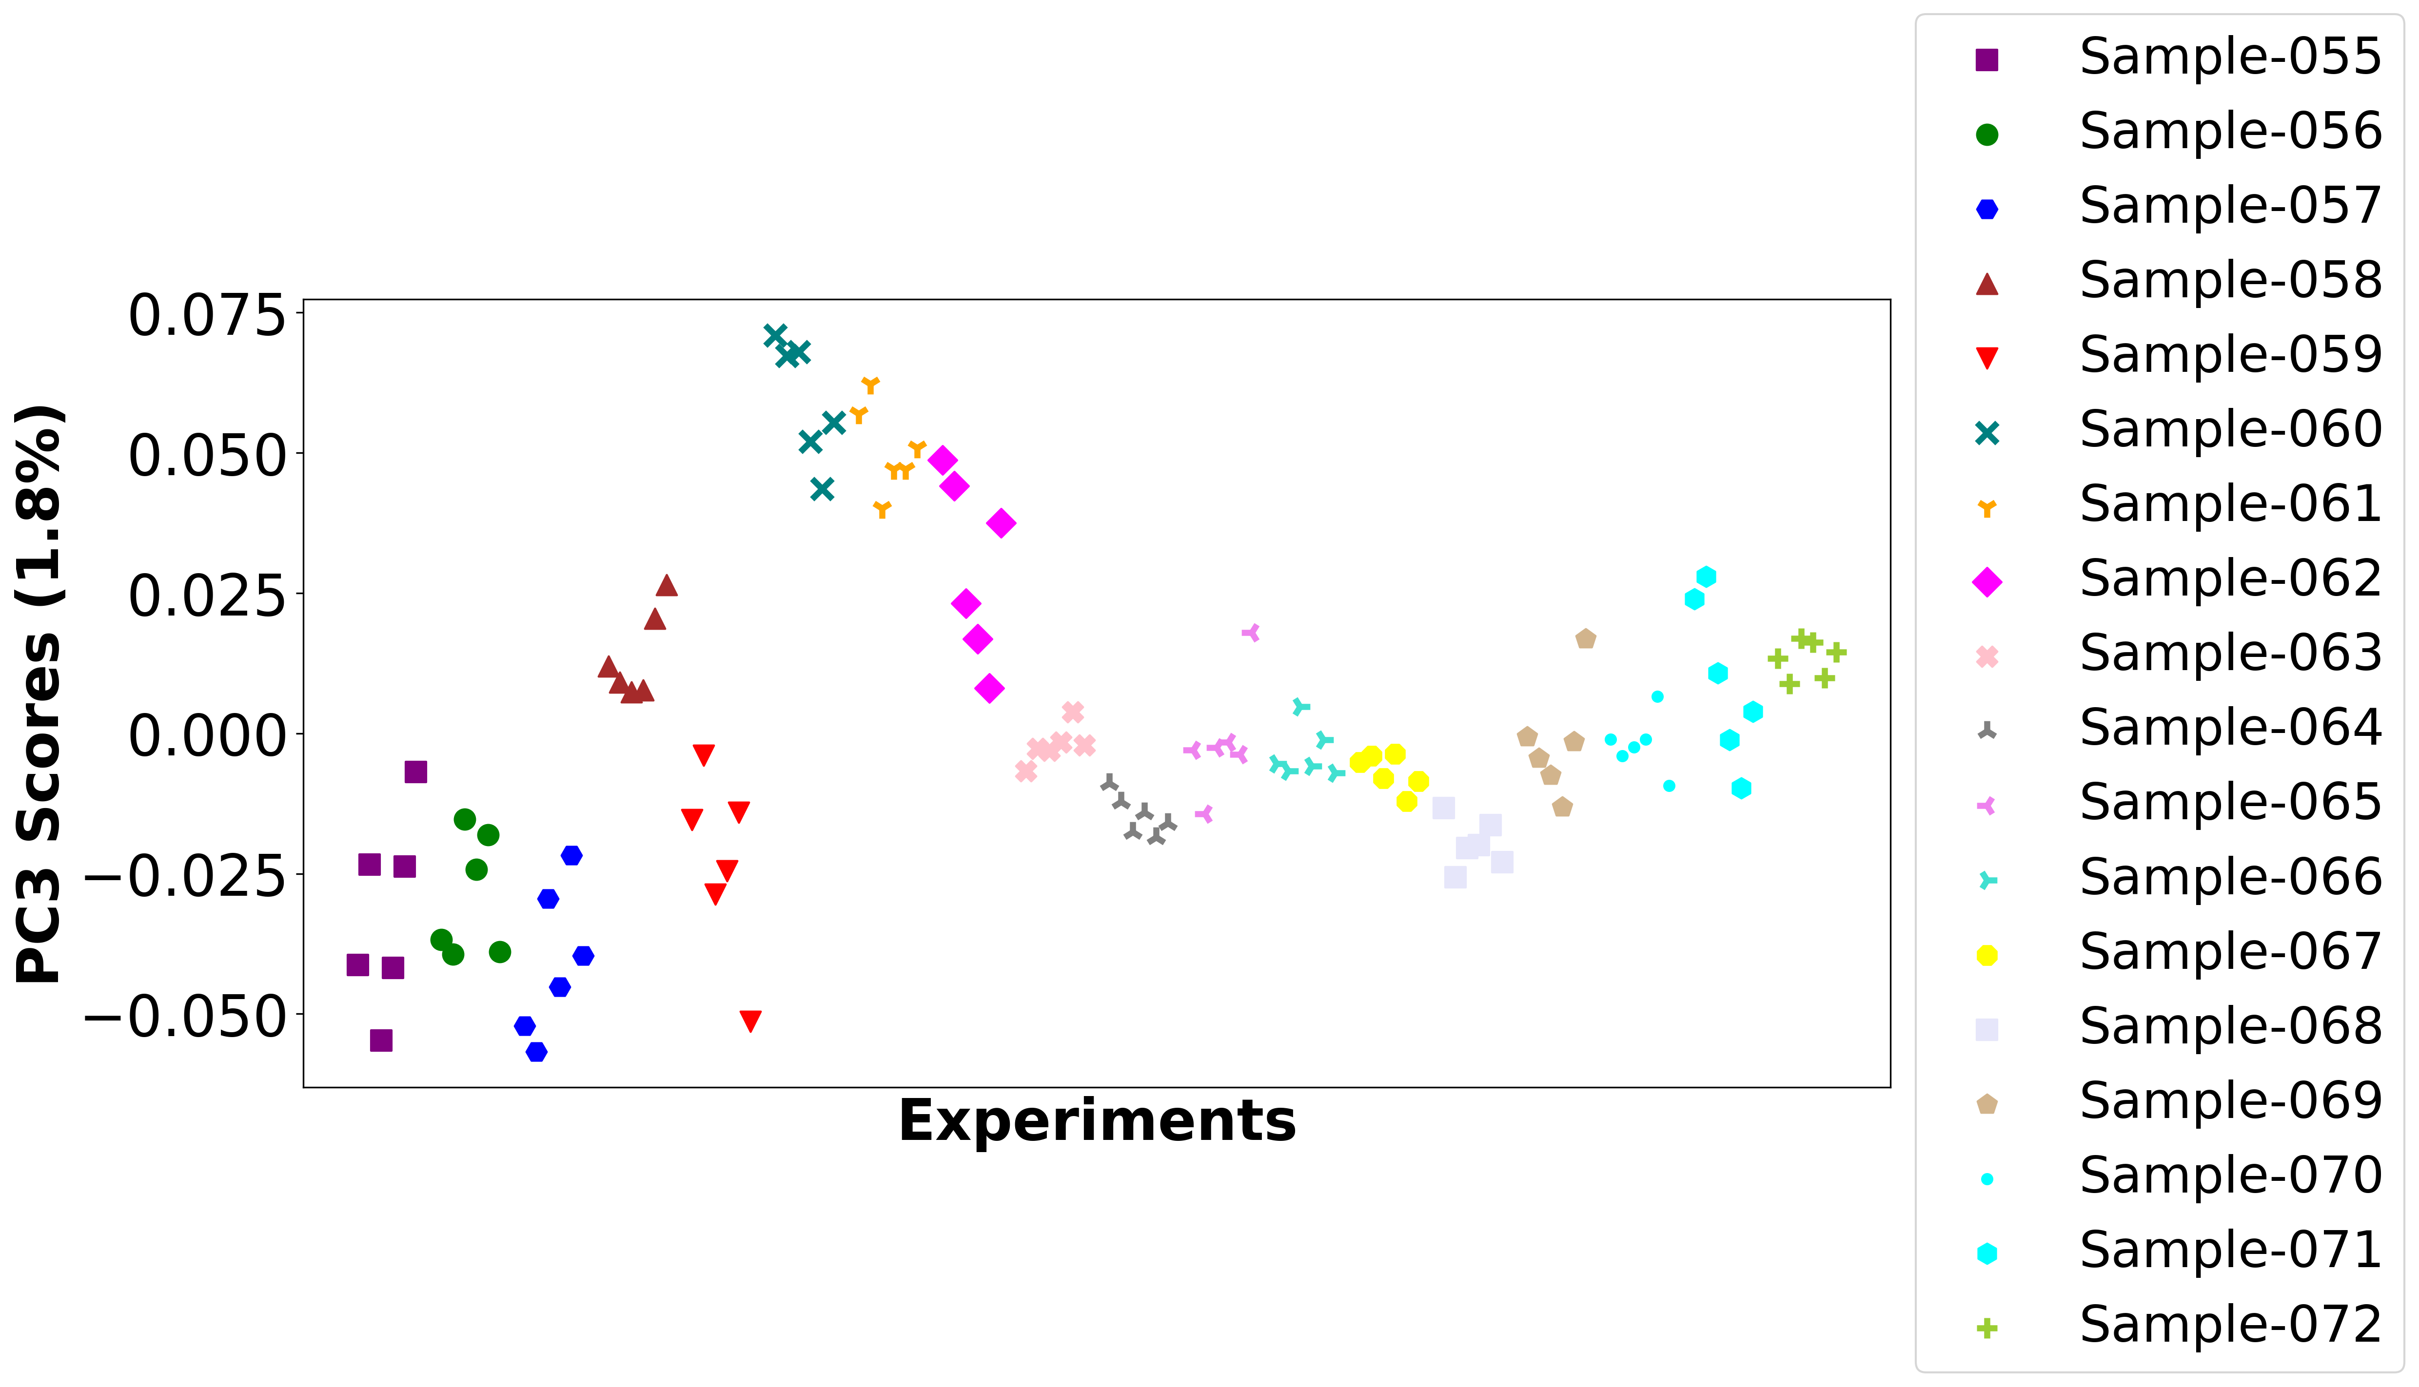

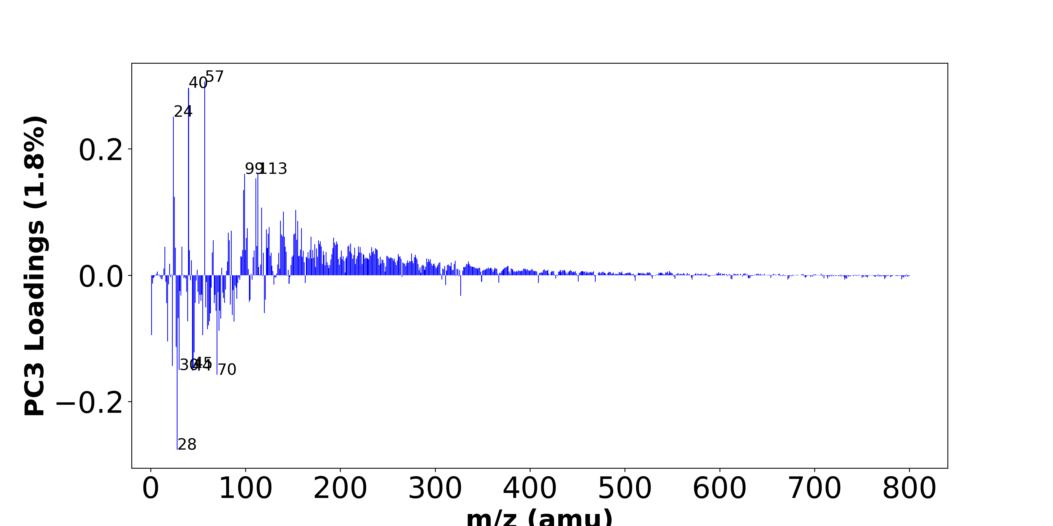

High score samples contain more:

* m/z 57 (C4H9+,CaOH+), m/z 40 (Ca+), m/z 24 (Mg+), m/z 99 (-), m/z 113 (-), m/z 111 (-), m/z 98 (-), m/z 25 (25Mg+), m/z 117 (-), m/z 153 (-), m/z 140 (-), m/z 137 (-), m/z 155 (-), m/z 125 (-), m/z 102 (-), m/z 159 (-), m/z 122 (-), m/z 85 (-), m/z 82 (-), m/z 152 (-),

Low score samples contain more:

* m/z 28 (Si+), m/z 70 (C4H8N+), m/z 44 (C2H6N+), m/z 30 (CH4N+,30Si+), m/z 45 (SiOH+,C2H5O+), m/z 23 (Na+), m/z 46 (Na2+,C2H8N+), m/z 27 (Al+,C2H3+), m/z 18 (NH4+), m/z 1 (H+), m/z 55 (C4H7+), m/z 72 (-), m/z 60 (-), m/z 61 (-), m/z 88 (C4H10NO+), m/z 39 (K+,C3H3+), m/z 62 (Na2O+), m/z 74 (-), m/z 29 (C2H5+,29Si+), m/z 86 (C5H12N+),
* Hydrocarbon, Nitrogen-contained organics

# Positive ion spectra, top positive loadings -- PC3

|  |  |  |  |  |  |  |
| --- | --- | --- | --- | --- | --- | --- |
| + loading | No. # | Unit Mass | Document Mass | Initial Peak Assignment | Measured Mass | Updated Peak Assignment |
|  | 1 | 57 | 57.0699,56.9648 | C4H9+,CaOH+ |  |  |
|  | 2 | 40 | 39.962 | Ca+ |  |  |
|  | 3 | 24 | 23.9845 | Mg+ |  |  |
|  | 4 | 99 |  |  |  |  |
|  | 5 | 113 |  |  |  |  |
|  | 6 | 111 |  |  |  |  |
|  | 7 | 98 |  |  |  |  |
|  | 8 | 25 | 24.9853 | 25Mg+ |  |  |
|  | 9 | 117 |  |  |  |  |
|  | 10 | 153 |  |  |  |  |
|  | 11 | 140 |  |  |  |  |
|  | 12 | 137 |  |  |  |  |
|  | 13 | 155 |  |  |  |  |
|  | 14 | 125 |  |  |  |  |
|  | 15 | 102 |  |  |  |  |
|  | 16 | 159 |  |  |  |  |
|  | 17 | 122 |  |  |  |  |
|  | 18 | 85 |  |  |  |  |
|  | 19 | 82 |  |  |  |  |
|  | 20 | 152 |  |  |  |  |

# Positive ion spectra, top negative loadings -- PC3

|  |  |  |  |  |  |  |
| --- | --- | --- | --- | --- | --- | --- |
| - loading | No. # | Unit Mass | Document Mass | Initial Peak Assignment | Measured Mass | Updated Peak Assignment |
|  | 1 | 28 | 27.9764 | Si+ |  |  |
|  | 2 | 70 | 70.0652 | C4H8N+ |  |  |
|  | 3 | 44 | 44.0495 | C2H6N+ |  |  |
|  | 4 | 30 | 30.0339,29.9732 | CH4N+,30Si+ |  |  |
|  | 5 | 45 | 44.9792,45.0335 | SiOH+,C2H5O+ |  |  |
|  | 6 | 23 | 22.9892 | Na+ |  |  |
|  | 7 | 46 | 45.979,46.0652 | Na2+,C2H8N+ |  |  |
|  | 8 | 27 | 26.981,27.023 | Al+,C2H3+ |  |  |
|  | 9 | 18 | 18.0339 | NH4+ |  |  |
|  | 10 | 1 | 1.0073 | H+ |  |  |
|  | 11 | 55 | 55.0543 | C4H7+ |  |  |
|  | 12 | 72 |  |  |  |  |
|  | 13 | 60 |  |  |  |  |
|  | 14 | 61 |  |  |  |  |
|  | 15 | 88 | 88.0757 | C4H10NO+ |  |  |
|  | 16 | 39 | 38.9632,39.023 | K+,C3H3+ |  |  |
|  | 17 | 62 | 61.974 | Na2O+ |  |  |
|  | 18 | 74 |  |  |  |  |
|  | 19 | 29 | 29.0386,28.9759 | C2H5+,29Si+ |  |  |
|  | 20 | 86 | 86.0965 | C5H12N+ |  |  |

# Positive ion spectra, molecular information from PC3 loadings plot

* The major positive PC3 loadings are m/z 57 (C4H9+,CaOH+), m/z 40 (Ca+), m/z 24 (Mg+), m/z 99 (-), m/z 113 (-), m/z 111 (-), m/z 98 (-), m/z 25 (25Mg+), m/z 117 (-), m/z 153 (-), m/z 140 (-), m/z 137 (-), m/z 155 (-), m/z 125 (-), m/z 102 (-), m/z 159 (-), m/z 122 (-), m/z 85 (-), m/z 82 (-), m/z 152 (-), , indicating they are more observed in high PC3 score samples.
* The major negative PC3 loadings are m/z 28 (Si+), m/z 70 (C4H8N+), m/z 44 (C2H6N+), m/z 30 (CH4N+,30Si+), m/z 45 (SiOH+,C2H5O+), m/z 23 (Na+), m/z 46 (Na2+,C2H8N+), m/z 27 (Al+,C2H3+), m/z 18 (NH4+), m/z 1 (H+), m/z 55 (C4H7+), m/z 72 (-), m/z 60 (-), m/z 61 (-), m/z 88 (C4H10NO+), m/z 39 (K+,C3H3+), m/z 62 (Na2O+), m/z 74 (-), m/z 29 (C2H5+,29Si+), m/z 86 (C5H12N+), , indicating they are more observed in high PC3 score samples.
* Hydrocarbon signals, such as m/z 27 (Al+,C2H3+), m/z 29 (C2H5+,29Si+), m/z 55 (C4H7+), , are majorly found in negative loadings, indicating that high PC3 score samples contain more Hydrocarbon.
* Nitrogen-contained organics signals, such as m/z 30 (CH4N+,30Si+), m/z 44 (C2H6N+), m/z 70 (C4H8N+), m/z 86 (C5H12N+), m/z 18 (NH4+), , are majorly found in negative loadings, indicating that high PC3 score samples contain more Nitrogen-contained organics.

# Positive ion spectra, PCA analysis results -- PC4

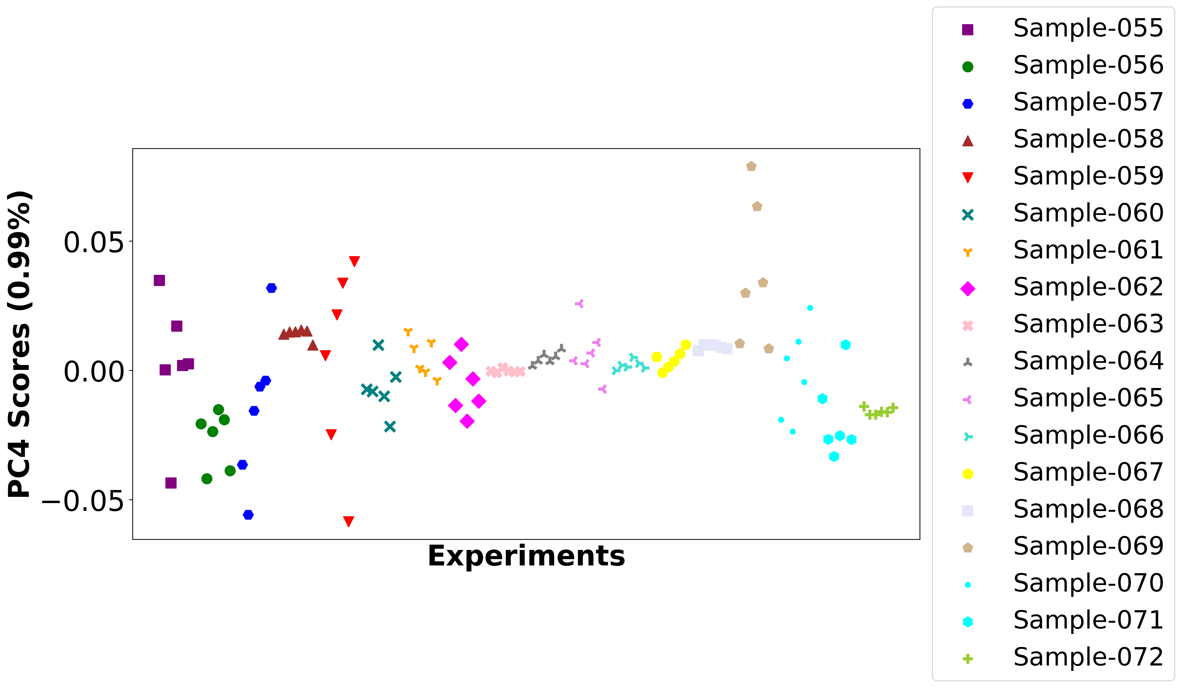

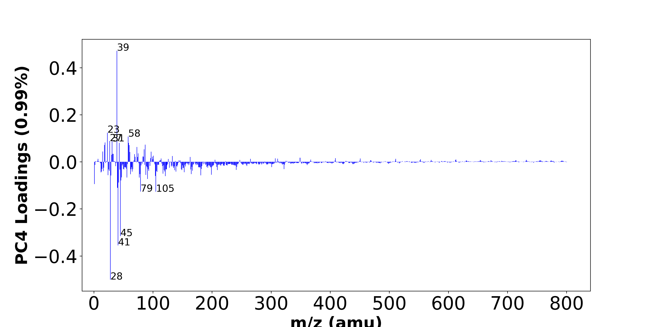

High score samples contain more:

* m/z 39 (K+,C3H3+), m/z 23 (Na+), m/z 58 (-), m/z 27 (Al+,C2H3+), m/z 31 (OCH3+), m/z 19 (OH3+), m/z 43 (C3H7+), m/z 59 (-), m/z 87 (-), m/z 18 (NH4+), m/z 60 (-), m/z 73 (SiC3H9+), m/z 85 (-), m/z 15 (CH3+), m/z 97 (-), m/z 61 (-), m/z 75 (-), m/z 32 (-), m/z 33 (-), m/z 69 (-),
* Hydrocarbon, Oxygen-contained organics, Nitrogen-contained organics

Low score samples contain more:

* m/z 28 (Si+), m/z 41 (C3H5+,41K+), m/z 45 (SiOH+,C2H5O+), m/z 105 (C8H9+), m/z 79 (-), m/z 40 (Ca+), m/z 1 (H+), m/z 42 (-), m/z 46 (Na2+,C2H8N+), m/z 91 (C7H7+), m/z 56 (Fe+,Si2+,C3H6N+), m/z 77 (C6H5+), m/z 47 (-), m/z 121 (-), m/z 104 (-), m/z 29 (C2H5+,29Si+), m/z 181 (-), m/z 24 (Mg+), m/z 88 (C4H10NO+), m/z 199 (-),
* Benzene-contained organics

# Positive ion spectra, top positive loadings -- PC4

|  |  |  |  |  |  |  |
| --- | --- | --- | --- | --- | --- | --- |
| + loading | No. # | Unit Mass | Document Mass | Initial Peak Assignment | Measured Mass | Updated Peak Assignment |
|  | 1 | 39 | 38.9632,39.023 | K+,C3H3+ |  |  |
|  | 2 | 23 | 22.9892 | Na+ |  |  |
|  | 3 | 58 |  |  |  |  |
|  | 4 | 27 | 26.981,27.023 | Al+,C2H3+ |  |  |
|  | 5 | 31 | 31.0179 | OCH3+ |  |  |
|  | 6 | 19 | 19.0179 | OH3+ |  |  |
|  | 7 | 43 | 43.0543 | C3H7+ |  |  |
|  | 8 | 59 |  |  |  |  |
|  | 9 | 87 |  |  |  |  |
|  | 10 | 18 | 18.0339 | NH4+ |  |  |
|  | 11 | 60 |  |  |  |  |
|  | 12 | 73 | 73.0469 | SiC3H9+ |  |  |
|  | 13 | 85 |  |  |  |  |
|  | 14 | 15 | 15.023 | CH3+ |  |  |
|  | 15 | 97 |  |  |  |  |
|  | 16 | 61 |  |  |  |  |
|  | 17 | 75 |  |  |  |  |
|  | 18 | 32 |  |  |  |  |
|  | 19 | 33 |  |  |  |  |
|  | 20 | 69 |  |  |  |  |

# Positive ion spectra, top negative loadings -- PC4

|  |  |  |  |  |  |  |
| --- | --- | --- | --- | --- | --- | --- |
| - loading | No. # | Unit Mass | Document Mass | Initial Peak Assignment | Measured Mass | Updated Peak Assignment |
|  | 1 | 28 | 27.9764 | Si+ |  |  |
|  | 2 | 41 | 41.0386,40.9613 | C3H5+,41K+ |  |  |
|  | 3 | 45 | 44.9792,45.0335 | SiOH+,C2H5O+ |  |  |
|  | 4 | 105 | 105.0699 | C8H9+ |  |  |
|  | 5 | 79 |  |  |  |  |
|  | 6 | 40 | 39.962 | Ca+ |  |  |
|  | 7 | 1 | 1.0073 | H+ |  |  |
|  | 8 | 42 |  |  |  |  |
|  | 9 | 46 | 45.979,46.0652 | Na2+,C2H8N+ |  |  |
|  | 10 | 91 | 91.0543 | C7H7+ |  |  |
|  | 11 | 56 | 55.9344,55.9534,56.0495 | Fe+,Si2+,C3H6N+ |  |  |
|  | 12 | 77 | 77.0386 | C6H5+ |  |  |
|  | 13 | 47 |  |  |  |  |
|  | 14 | 121 |  |  |  |  |
|  | 15 | 104 |  |  |  |  |
|  | 16 | 29 | 29.0386,28.9759 | C2H5+,29Si+ |  |  |
|  | 17 | 181 |  |  |  |  |
|  | 18 | 24 | 23.9845 | Mg+ |  |  |
|  | 19 | 88 | 88.0757 | C4H10NO+ |  |  |
|  | 20 | 199 |  |  |  |  |

# Positive ion spectra, molecular information from PC4 loadings plot

* The major positive PC4 loadings are m/z 39 (K+,C3H3+), m/z 23 (Na+), m/z 58 (-), m/z 27 (Al+,C2H3+), m/z 31 (OCH3+), m/z 19 (OH3+), m/z 43 (C3H7+), m/z 59 (-), m/z 87 (-), m/z 18 (NH4+), m/z 60 (-), m/z 73 (SiC3H9+), m/z 85 (-), m/z 15 (CH3+), m/z 97 (-), m/z 61 (-), m/z 75 (-), m/z 32 (-), m/z 33 (-), m/z 69 (-), , indicating they are more observed in high PC4 score samples.
* The major negative PC4 loadings are m/z 28 (Si+), m/z 41 (C3H5+,41K+), m/z 45 (SiOH+,C2H5O+), m/z 105 (C8H9+), m/z 79 (-), m/z 40 (Ca+), m/z 1 (H+), m/z 42 (-), m/z 46 (Na2+,C2H8N+), m/z 91 (C7H7+), m/z 56 (Fe+,Si2+,C3H6N+), m/z 77 (C6H5+), m/z 47 (-), m/z 121 (-), m/z 104 (-), m/z 29 (C2H5+,29Si+), m/z 181 (-), m/z 24 (Mg+), m/z 88 (C4H10NO+), m/z 199 (-), , indicating they are more observed in high PC4 score samples.
* Hydrocarbon signals, such as m/z 15 (CH3+), m/z 27 (Al+,C2H3+), m/z 43 (C3H7+), , are majorly found in positive loadings, indicating that high PC4 score samples contain more Hydrocarbon.
* Oxygen-contained organics signals, such as m/z 31 (OCH3+), m/z 19 (OH3+), , are majorly found in positive loadings, indicating that high PC4 score samples contain more Oxygen-contained organics.
* Nitrogen-contained organics signals, such as m/z 18 (NH4+), , are majorly found in positive loadings, indicating that high PC4 score samples contain more Nitrogen-contained organics.
* Benzene-contained organics signals, such as m/z 91 (C7H7+), m/z 77 (C6H5+), m/z 105 (C8H9+), , are majorly found in negative loadings, indicating that high PC4 score samples contain more Benzene-contained organics.

# Positive ion spectra, PCA analysis results -- PC5

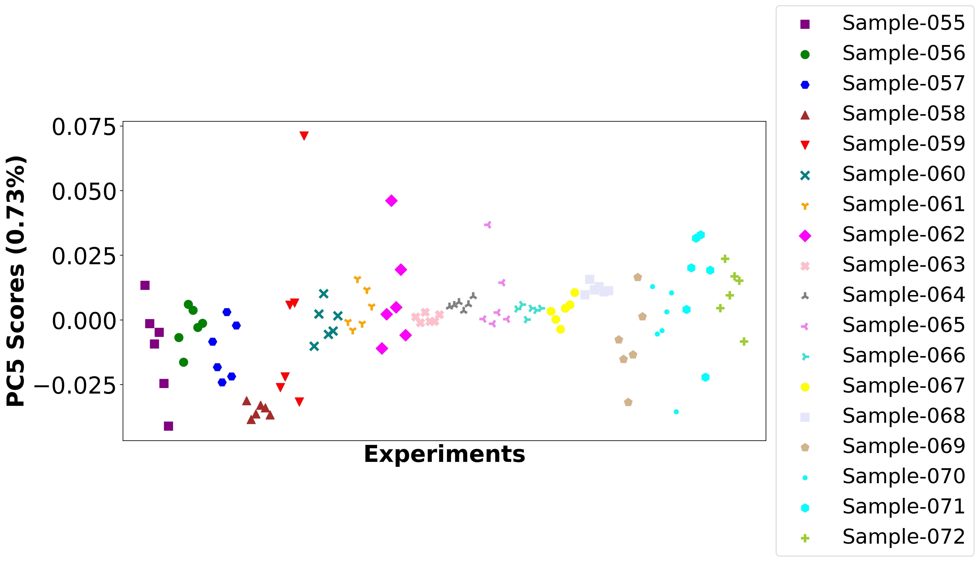

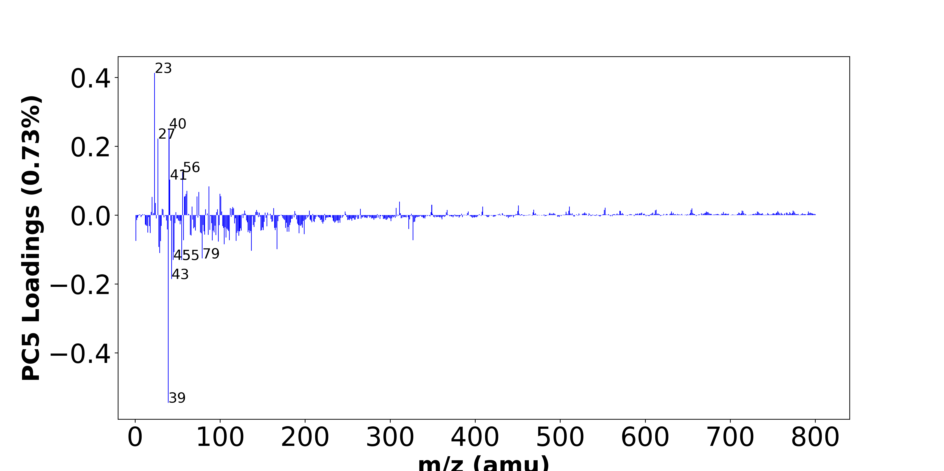

High score samples contain more:

* m/z 23 (Na+), m/z 40 (Ca+), m/z 27 (Al+,C2H3+), m/z 56 (Fe+,Si2+,C3H6N+), m/z 41 (C3H5+,41K+), m/z 87 (-), m/z 61 (-), m/z 75 (-), m/z 100 (-), m/z 60 (-), m/z 59 (-), m/z 101 (-), m/z 73 (SiC3H9+), m/z 58 (-), m/z 20 (Ca++), m/z 311 (-), m/z 24 (Mg+), m/z 349 (-), m/z 451 (-), m/z 511 (-),
* Hydrocarbon

Low score samples contain more:

* m/z 39 (K+,C3H3+), m/z 43 (C3H7+), m/z 55 (C4H7+), m/z 45 (SiOH+,C2H5O+), m/z 79 (-), m/z 29 (C2H5+,29Si+), m/z 46 (Na2+,C2H8N+), m/z 137 (-), m/z 167 (-), m/z 28 (Si+), m/z 105 (C8H9+), m/z 98 (-), m/z 30 (CH4N+,30Si+), m/z 119 (-), m/z 1 (H+), m/z 91 (C7H7+), m/z 57 (C4H9+,CaOH+), m/z 327 (-), m/z 111 (-), m/z 107 (-),
* Nitrogen-contained organics, Benzene-contained organics

# Positive ion spectra, top positive loadings -- PC5

|  |  |  |  |  |  |  |
| --- | --- | --- | --- | --- | --- | --- |
| + loading | No. # | Unit Mass | Document Mass | Initial Peak Assignment | Measured Mass | Updated Peak Assignment |
|  | 1 | 23 | 22.9892 | Na+ |  |  |
|  | 2 | 40 | 39.962 | Ca+ |  |  |
|  | 3 | 27 | 26.981,27.023 | Al+,C2H3+ |  |  |
|  | 4 | 56 | 55.9344,55.9534,56.0495 | Fe+,Si2+,C3H6N+ |  |  |
|  | 5 | 41 | 41.0386,40.9613 | C3H5+,41K+ |  |  |
|  | 6 | 87 |  |  |  |  |
|  | 7 | 61 |  |  |  |  |
|  | 8 | 75 |  |  |  |  |
|  | 9 | 100 |  |  |  |  |
|  | 10 | 60 |  |  |  |  |
|  | 11 | 59 |  |  |  |  |
|  | 12 | 101 |  |  |  |  |
|  | 13 | 73 | 73.0469 | SiC3H9+ |  |  |
|  | 14 | 58 |  |  |  |  |
|  | 15 | 20 | 19.9807 | Ca++ |  |  |
|  | 16 | 311 |  |  |  |  |
|  | 17 | 24 | 23.9845 | Mg+ |  |  |
|  | 18 | 349 |  |  |  |  |
|  | 19 | 451 |  |  |  |  |
|  | 20 | 511 |  |  |  |  |

# Positive ion spectra, top negative loadings -- PC5

|  |  |  |  |  |  |  |
| --- | --- | --- | --- | --- | --- | --- |
| - loading | No. # | Unit Mass | Document Mass | Initial Peak Assignment | Measured Mass | Updated Peak Assignment |
|  | 1 | 39 | 38.9632,39.023 | K+,C3H3+ |  |  |
|  | 2 | 43 | 43.0543 | C3H7+ |  |  |
|  | 3 | 55 | 55.0543 | C4H7+ |  |  |
|  | 4 | 45 | 44.9792,45.0335 | SiOH+,C2H5O+ |  |  |
|  | 5 | 79 |  |  |  |  |
|  | 6 | 29 | 29.0386,28.9759 | C2H5+,29Si+ |  |  |
|  | 7 | 46 | 45.979,46.0652 | Na2+,C2H8N+ |  |  |
|  | 8 | 137 |  |  |  |  |
|  | 9 | 167 |  |  |  |  |
|  | 10 | 28 | 27.9764 | Si+ |  |  |
|  | 11 | 105 | 105.0699 | C8H9+ |  |  |
|  | 12 | 98 |  |  |  |  |
|  | 13 | 30 | 30.0339,29.9732 | CH4N+,30Si+ |  |  |
|  | 14 | 119 |  |  |  |  |
|  | 15 | 1 | 1.0073 | H+ |  |  |
|  | 16 | 91 | 91.0543 | C7H7+ |  |  |
|  | 17 | 57 | 57.0699,56.9648 | C4H9+,CaOH+ |  |  |
|  | 18 | 327 |  |  |  |  |
|  | 19 | 111 |  |  |  |  |
|  | 20 | 107 |  |  |  |  |

# Positive ion spectra, molecular information from PC5 loadings plot

* The major positive PC5 loadings are m/z 23 (Na+), m/z 40 (Ca+), m/z 27 (Al+,C2H3+), m/z 56 (Fe+,Si2+,C3H6N+), m/z 41 (C3H5+,41K+), m/z 87 (-), m/z 61 (-), m/z 75 (-), m/z 100 (-), m/z 60 (-), m/z 59 (-), m/z 101 (-), m/z 73 (SiC3H9+), m/z 58 (-), m/z 20 (Ca++), m/z 311 (-), m/z 24 (Mg+), m/z 349 (-), m/z 451 (-), m/z 511 (-), , indicating they are more observed in high PC5 score samples.
* The major negative PC5 loadings are m/z 39 (K+,C3H3+), m/z 43 (C3H7+), m/z 55 (C4H7+), m/z 45 (SiOH+,C2H5O+), m/z 79 (-), m/z 29 (C2H5+,29Si+), m/z 46 (Na2+,C2H8N+), m/z 137 (-), m/z 167 (-), m/z 28 (Si+), m/z 105 (C8H9+), m/z 98 (-), m/z 30 (CH4N+,30Si+), m/z 119 (-), m/z 1 (H+), m/z 91 (C7H7+), m/z 57 (C4H9+,CaOH+), m/z 327 (-), m/z 111 (-), m/z 107 (-), , indicating they are more observed in high PC5 score samples.
* Hydrocarbon signals, such as m/z 27 (Al+,C2H3+), m/z 41 (C3H5+,41K+), , are majorly found in positive loadings, indicating that high PC5 score samples contain more Hydrocarbon.
* Nitrogen-contained organics signals, such as m/z 30 (CH4N+,30Si+), , are majorly found in negative loadings, indicating that high PC5 score samples contain more Nitrogen-contained organics.
* Benzene-contained organics signals, such as m/z 91 (C7H7+), m/z 105 (C8H9+), , are majorly found in negative loadings, indicating that high PC5 score samples contain more Benzene-contained organics.